LaSPACE Final Report Guidance
This Final Report if for completed projects. For progress reports, NCE requests, and amendments, utilize the separate LA NASA Space Grant and LA NASA EPSCoR Progress Report accessible from the

Final Report Introduction
Final Reports are due 30 days after your project’s official end date. Failure to submit a timely and complete Final Report can result in a loss of eligibility for future funding. Incorrect or incomplete answers will require you to resubmit the entire Final Report. You may prepare your responses in advance using this guidance document. This guidance is structured to parallel the online form.
This form is for Final Reports on completed projects. For progress reports, NCE requests, and amendments, utilize the separate LA NASA Space Grant and LA NASA EPSCoR Progress Report from the LaSPACE Website Document Center
- Who should be completing this form
  - LaSSO & LURA Final Reports are co-written by the Project Lead/PI faculty mentor & funded student.
  - GSRA Final Reports are typically written by the funded student with input from the Project Lead/PI faculty mentor.
  - GIRAF, GPS, & Intern Final Reports are written by the funded student.
  - All other programs require Final Reports to be written by the Project Lead/PI unless otherwise stated in program guidelines. Ultimately, any project with a subaward & named PI is the responsibility of that PI. Any funding issued directly to a student without a PI is the responsibility of the student.
  - If you have questions about the Final Report, contact LaSPACE@lsu.edu.

- Required File Uploads
  - As part of the final report, you will need to upload some additional files. Use of these provided file templates is required and ensures it is properly formatted for reporting to NASA Program management. Templates for all 3 files are downloaded from the Document Center on the LaSPACE website as shown below.
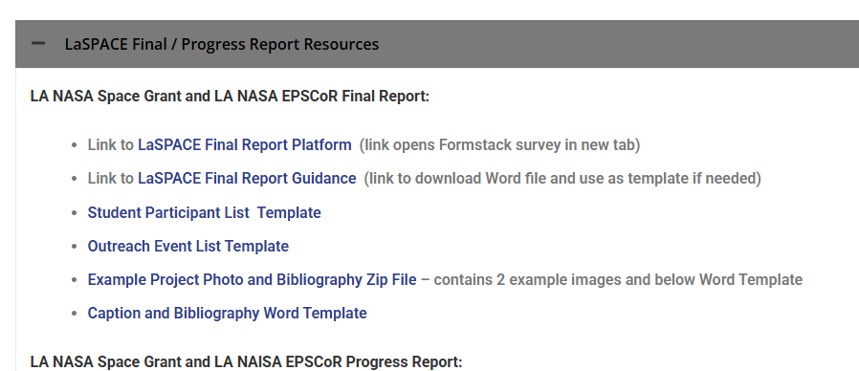
  - Student Participant List
    - This is an Excel table of naming all supported students, total financial support, and contact hours.
  - Outreach Event List
    - If your project includes a K-12 or Public Outreach component, provide the number of participants by type and event using the provided Excel template/
  - Project Images and Bibliography
    - In a combined zip archive, provide at least two project photos and a Word document with descriptive captions and a project bibliography.

- Save and Resume Later

  - This Final Report platform allows you to “Save and Resume Later.” To save your current draft, click on the Save and Resume link (as shown to the right).
  - After confirming your save, you will get a pop-up with a unique link generated by Formstack. We recommend you immediately copy this link somewhere you will not lose it.
  - You may also enter your email address and click “Send save and resume link” to receive a copy of the link via your email. It will come from Colleen Fava (LaSPACE/LSU) via Formstack.
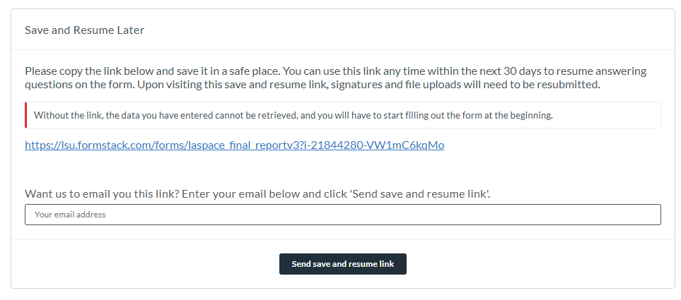
  - NOTE: This only saves the current draft of the form, so this process must be repeated every time you wish to save your progress
- Confirmation email
  - Once you submit your completed Final Report, you will receive an automatic confirmation email containing a PDF with your Final Report answers. Keep that email and PDF for your records.
- Useful links
  - Link to Online LA NASA Space Grant and LA NASA EPSCoR Final Report platform
  - Link to LaSPACE Student Participant Information Form (same link for ALL students)
  - Link to LaSPACE NASA Media Release Form (for both adults and minors)

FINAL REPORT SECTIONS

Project Information
This section covers the identifying details about your project. Please have ready: the name of the program this project is funded under, the awarded period of performance, and the PO or GR numbers.
- Primary Institution: Select the primary institution hosting your project. Examples below.
  - If you are a high school student, select the institution where your project is taking place.
    - If you are a high school student at LSMSA and your project is at Northwestern State University of Louisiana, select NSULA.
- LA NASA Space Grant or EPSCoR Program: Select the program you are writing a final report for.
- Start Date: What is the start date (MM/DD/YYYY) of your award?
  - This is the start date listed in your award letter.
  - Interns: This is the start date of your internship.
- End Date: What is the end date (MM/DD/YYYY) of your award?
  - This is the end date listed in your award letter; if you received an NCE, put the modified end date here.
  - Interns: This is the end date of your internship.
- What is the PO # or GR # assigned to your project?
  - For non-LSU subaward projects:
    - List the PO # assigned to your project. It starts with PO-0000.
    - This is the "Subaward No." on the 1st page of your subaward contract.
    - Do NOT provide us your institution's internal project numbers.
  - For LSU projects:
    - List the grant number assigned to your project. It starts with GR-000.
    - If you don't know this number, check with the grant manager in your department.
  - Interns, RockOn Teams, GPS Scholars will not need to complete this field

Project Lead/PI and Direct-Funded Student Info
The next section collects basic information about the Project Lead/PI and direct-funded student (if applicable). Please have ready: first & last names, phone numbers, and email addresses.
- Project Lead/PI

  - Interns: This is you! You will also enter your information into the direct-funded student info fields.
  - GPS: This is the LaSPACE Director.
    - You will provide their first name, last name, phone number, and email address.
  - All other projects: This is the faculty or staff member identified as the Project Lead/PI in your proposal.
    - You will provide their first name, last name, phone number, and email address.

- Direct-Funded Student (GIRAF, GPS, GSRA, Intern, LaSSO, or LURA)
  - You will provide the direct-funded student’s first name, last name, phone number, and email address.

Project Report Narrative
The following section consists of short narrative descriptions of the project and the experiences of both faculty and student participants.

General Narrative
- Describe the funded project for a general audience (150 words or less).
  - Example from a LaACES project: University physics and engineering technology students, under the guidance of faculty, completed a year-long Louisiana Aerospace Catalyst Experiences for Students (LaACES) project that was funded by the Louisiana Space Grant Consortium. This project culminated in the launch of their instruments by a weather balloon to an altitude of 100,000 ft and subsequent recovery by parachute. In this project, the students learned electronics, programming, project management, and atmospheric sciences. Their experiments to measure the atmospheric pressure, temperature, humidity, and the effect of the atmosphere on the solar spectrum were successful.
- List the funded goals & objectives (500 words or less).
  - Example from a LURA project: #1: Learn basic organic synthesis and purification, coordination chemistry and characterization. During this project I prepared terpyridine ligands, prepared beta-diketonate lanthanide complexes and characterized using IR, NMR and XRD (powder). I was also able to assist with some UV-Vis data collection. Also, I was paid (separate funding) for running DSC analysis on polymer samples for a mechanical engineering professor based on my experience running DSC for compounds and polymer samples for this project. #2 Learn more polymer chemistry. I was able to dope my compounds into polymers and cure them into optically clear materials. I found an efficient methodology for sample preparation that requires minimal time but allows for reproducible fabrication of clear plastics. #3 Work on an interdisciplinary project. For this project, I was able to interact and work alongside physicists. I had the opportunity to assist in some preliminary data collection. #4: Improve my communication skills. For this project, I was able to present posters at a conference and I presented lectures on Zoom to graduate students and faculty.
- Share major accomplishments from this project (300 words or less).
  - Example from a GSRA project: Conferences: Louisiana Academy of Sciences; College of Applied and Natural Sciences Research Symposium. Other accomplishments include a student earning a postbac spot with the NIH (included hyperlink to LaTech press release).

Student Reflection
Collect responses from all students supported on this activity. We have included guiding questions and example responses from other project reports. For projects with multiple students supported on one award, identify each student by name at the start of each reflection. You may provide shorter statements for larger team projects.
- Student Reflection (500 words or less) written for a public audience. Guiding questions below.
  - Start with a short description of the research project appropriate for a general audience (3-5 sentences).
  - If you are an intern, answer the questions below from an internship perspective and remove the research aspect if it is not applicable to your experience.
  - What additional activities did you participate in (outside of the research) during the course of the project, such as conference attendance, paper/poster presentations, networking events, etc.? What technical and/or non-technical skills did you learn or hone? What wins did you experience (not just with research)? What growth opportunities or challenges did you overcome? How will this experience influence your professional and academic trajectory? What are your future plans? How will you use your experience moving forward?
  - Example: Before meeting my mentor and joining his lab, I had no idea that I could pursue a career in medical research. I thought there were only two paths: medical school to become a practicing physician or graduate school to do research. While I’m still planning to apply to med school, I’m very interested in the possibility of a joint MD/PhD with a focus on space medicine. It would be really cool to work to keep astronauts healthy and safe. I also am very excited about how space medicine could actually improve health care on earth for regular people. I would not have fully understood this career path without the opportunity to get paid and work in this lab all year.
- Unique Benefits to Student(s)
  - Tell us what, if anything, this project provided to you that you would not have received without participating in this project. This could be a specific skill development, experiences, training, financial or personal support, and/or other resources of importance to you. If you do not believe this project made a unique contribution, please enter n/a.
  - Example: Few engineering sophomores in my school are able to work on a complete project lifecycle. I feel very fortunate to know early on that I can work on a team with people from different backgrounds and fields to produce a fully developed payload ready for flight. I loved troubleshooting with my peers and being challenged, but also encouraged by our instructors. I feel like I will have an edge later when I’m working on my senior design project, regardless of what the topic is.
- Direct Impact on Student(s)
  - What, if any, impact did participation in this funded project influence your career / educational path? Specifically, have you changed course due to this experience? Been reassured in your choice? Been scared away from your choice? Identified new options? etc.
  - Example: Before getting to work in this lab with a team of supportive mentors I was concerned that I was not suited to a life in research. I learned that scientists are often well-rounded individuals and that making mistakes is part of the scientific process. I also experienced moments when my creative instincts were put to good use, like when I was asked to create a new lab safety poster. I feel more confident in my career path.

Project Lead / Principal Investigator Reflection
The next 3 questions are specifically for the Project Lead/PI Reflection. This is required from the Project Lead/PI. We strongly encourage you to share additional comments from other faculty or staff working on this project. Please keep your total response for this section less than 500 words.
Interns & GPS Students: Enter N/A for each of these 4 questions.
GSRA Students: Make sure you get this content from your Faculty PI.
      - Project Lead/PI Reflection written for a public audience. Guiding questions below.
        - Start with a short description of the research project appropriate for a general audience (3-5 sentences).
        - Explain how this award directly impacted your work life: pay particular attention to 1) how you grew and/or employed your mentorship skills and 2) how this award supported your own professional development goals.
        - Share as appropriate how this award impacted you beyond the two categories listed above.
        - Will you continue to propose to LaSPACE / LA NASA EPSCoR funded programs? If yes, which ones and why. If no, please tell us why.
      - Project Lead/PI Mentorship Achievements
        - What additional activities did your students experience outside of the project like conference/competition attendance, paper/poster presentations, networking events, etc.? What technical and/or non-technical skills did your students learn or hone? What growth opportunities or challenges did your students overcome? How do you expect this experience to influence your students’ professional and academic trajectories?
        - Example: Students working for me are required to attend weekly lab meetings. After about 2 months, they are expected to contribute by providing short reports on their activities. Advanced undergraduates are invited to work as co-authors on publications of research that they actively contributed to, and all students are expected to participate in at least one professional development activity outside the lab, such as presenting at research symposium on campus and/or presenting at the annual meeting. Julie Smith, a student funded under this award, presented a poster at the prestigious AGU conference held in New Orleans this year; I encourage all students who are ready to begin submitting to national and international conferences.
      - Direct Impact on Project Lead/PI
        - Did this funding make a unique contribution to your professional success? If yes, please share details. If no, enter N/A.
        - Example: As an early career faculty member, I have limited funding available to support activities in my lab. Without this LaSSO award, I would not have been able to hire an undergraduate student researcher to work 15 hours a week in my lab for the academic year. My student was able to learn valuable skills for her future career, while I secured much needed support for basic experimental tasks.

Project Results and Dissemination
Enter the total number of data products/publications and authors counts for products produced as a result of this funding in the following categories:
- Peer-Reviewed Publications and Author Types
- Other Publications and Author Types
- Paper Presentations and Author Types
- Oral Presentations and Author Types
- Poster Presentations and Author Types
- Awards, honors, certificates, or recognitions received
- Patents and Technology Transfers

Student Participant List
- Upload Student Participant List
  - File Name
    - Rename your file from Institution-Program-Name-Year-Students.xlsx, replacing Institution, Program, Name, and Year.
    - Institution should be your institution (ex. LSU, LaTech, etc.)
    - Name Should be PI’s Last Name
    - Year should be the ending year for the project
  - For each supported student participant, using the provided:
    - Full name
    - Classification (high school, undergraduate, or graduate)
    - Amount of funding received from the LaSPACE award
    - Number of direct contact hours
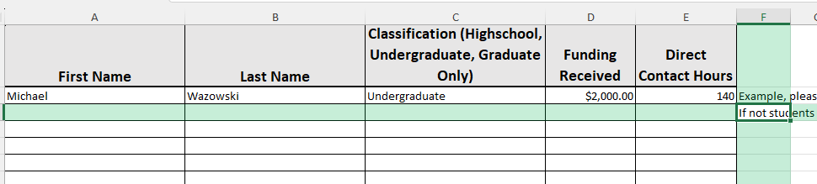
  - If there were no students, enter None on the first line and uploaded that file.
- Confirm that you have verified that all student participants have completed the LaSPACE Student Participant Information Form. Do not include copies of the participant forms in your report.
  - Link to the LaSPACE Student Participant Information Form
  - Note: Students should have received an email confirmation after completing their form and they were instructed to forward the confirmation email to PIs. Check your email and/or check with your students for such confirmation.

K12 and General Public Outreach

K-12 and General Public Outreach Event List
If your project DID include an outreach component to either a K-12 audience and/or the general public, you will need to upload a breakdown of participation numbers.
- Upload the Outreach Event List using the provided Excel template.
  - File Name
    - Rename your file from Institution-Program-Name-Year-Outreach.xlsx, replacing Institution, Program, Name, and Year.
    - Institution should be your institution (ex. LSU, LaTech, etc.)
    - Name Should be PI’s Last Name
    - Year should be the ending year for the project
  - For each event or outreach activity, provide the following:
    - Name of Event
    - Date of Event
    - Location of Event
    - Number of participants in the following categories

Students
- Only count students for school/classroom-based events OR events limiting participation to a specific grade level.
- If the event was a public event, count school-aged children attendees as “general public/other participants.”
Categories for Student Learners:
- Elementary Students (grades K – 5)
- Middle School Students (grades 6 – 8)
- High School Students (grades 9 – 12)
- Undergraduate Students (Freshmen – Seniors)
- Graduate Students (Master’s – Doctoral)
- Post Docs

Educators
- Only count students for school/classroom-based events OR events limiting participation to a specific grade level. If it was a public event, count educator attendees as “general public/other participants.”
Categories for Educator Learners:
- Elementary School Educators (grades K – 5)
- Middle School Educators (grades 6 – 8)
- High School Educators (grades 9 – 12)
- Higher Ed. Faculty
- Administrators (formal education administrative staff)
- Informal Educators (staff from museums, science centers, planetariums, libraries, youth-serving organizations, government, industry, other non-profit organizations)
- Pre-Service Educators
- Homeschool Educators (homeschool K-12)

General Public/Other Participants
- For events open to the general public, provide your best estimate of the number of attendees. If you can break out the number of under-13 attendees. You may just provide the total number of attendees if that is the only information you have.

Project Photos and Bibliography
The final step of the report is to upload a Zip file containing project images and supplementary Word Document.
- Naming your zip file folder
  - File Name
    - Rename your file from Institution-Program-Name-Year-Zip.zip, replacing Institution, Program, Name, and Year.
    - Institution should be your institution (ex. LSU, LaTech, etc.)
    - Name Should be PI’s Last Name
- Project Images
  - At a minimum: Include two photos featuring supported participants (including students, faculty, and outreach attendees) performing funded activities. We encourage the submission of additional photos, especially for projects with numerous students. Additional Images are welcome, but all images should have a corresponding caption
  - Name photos as follows: Image 1, Image 2, Image 3, and so forth
    - JPG and PNG file types are preferred
  - Each file name must correspond to the list of comprehensive captions in the Word document.
- Word document
  - This file will contain comprehensive image/figure captions, citations for any Data Products resulting from the project, and list of outside Collaborators
  - File Name
    - Rename your file from Institution-Program-Name-Year-Captions.docx, replacing Institution, Program, Name, and Year.
    - Institution should be your institution (ex. LSU, LaTech, etc.)
    - Name Should be PI’s Last Name
  - Captions
    - List out the file names based on how you named them (e.g. Image 1, Image 2) followed by a colon (:)
    - After the colon (:), include a comprehensive caption answering the following questions:
      - Who is in the photo? (full names)
      - What is happening? What information is the figure imparting?
      - Where are the photographed people? Where was the figure shared if it’s a poster that was presented? (city, state, conference name, etc.)
      - When was the photo taken? (month, date, & year is preferred)
    - EXAMPLE Image 1: Mike the Tiger working with photovoltaic material in the Tiger Stripes Lab at LSU on March 5, 2023.
  - Other Media Links
    - If you have other media or news stories related to the project that you would like to share, provide a link and a short description.
    - For example, social media posts about the project, a video of a student presenting, or a public media interview would all be appropriate to link in this section.
  - Data Products and Dissemination
    - Using the provided tables, list any publications, presentations, etc., resulting from the project.
    - The table formats are from a standard NASA Research Progress format; please use the provided format.
    - Do not include pending publications.
  - List of Collaborators
    - If your project involved collaboration with NASA or Industry Partners, list the collaborators and their role in the project in the provided tables

Upload the required Zip File
Add your image files and Word Document to the properly named Zip file and upload to the form.
Zip is the only accepted file format. You will receive an error message after attempting to submit a Final Report containing non-zip file type uploads.
Follow the Zip File Folder Upload Instructions above before uploading your materials. Note that there is a combined 2GB upload limit.

Confirmation of LaSPACE NASA Media Release Form Submissions
- NASA Media Release Forms are required for all identifiable individuals in submitted materials.
- The Project Lead/PI is required to confirm that all identifiable individuals, both adults and minors, have completed a form.
- The LaSPACE NASA Media Release Form is available in an online submission format (click here for link).

Final Notes
After clicking the final submit button, it may take a moment for your Final Report submission to process if your zip file folder upload is large. DO NOT refresh the page, click the back button, or close your browser!
Once your submission is processed, a new screen will appear thanking you for submitting your Final Report. You will also receive a confirmation email (sent to the Project Lead/PI email address provided) which will include a PDF copy of your full report. After you receive the confirmation email, it will be safe to close your browser.

