Sample Logic Model

Problem Statement:
Assumptions:
Goal(s):

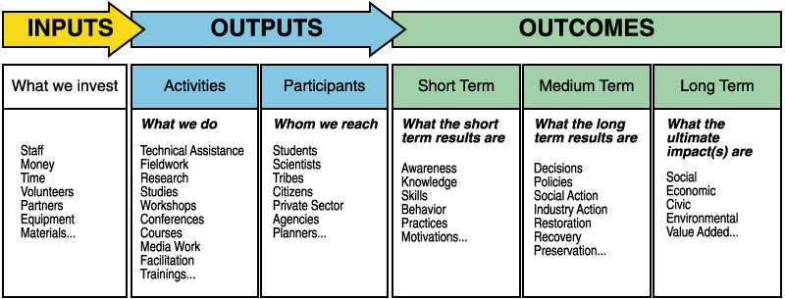

Be sure to indicate how OUTCOMES will be measureable.

