FOR IMMEDIATE RELEASE – Wednesday, May 5, 2021
Prestigious NASA Public Service Medal Awarded to LSU Physics Professor, LA NASA Space Grant & EPSCoR Director
BATON ROUGE, LA –T. Gregory Guzik, LSU Physics Professor and Director of the Louisiana Space Grant NASA EPSCoR (LaSPACE) programs has been awarded the 2020 NASA Outstanding Public Leadership Medal (OPLM). This prestigious NASA recognition is awarded to non-Government individuals or to an individual who was not a Government employee during the period in which the accomplishment was achieved, for notable leadership accomplishments that have significantly influenced the NASA Mission. The official NASA award citation reads: “In recognition for many years of exceptional dedication and public service inspiring and teaching the next generation of leaders in science, engineering and technology.”
Guzik was nominated in recognition of his leadership in the scientific ballooning community by Joyce Winterton, Senior Advisor for Education and Leadership Development at NASA Wallops Flight Facility and Debbie Fairbrother, Chief of the NASA Balloon Program Office. Their letter of nomination explicitly references Guzik’s exceptional foresight and dedication in establishing and maintaining two distinguished scientific ballooning programs for students, the international High-Altitude Student Platform (HASP) and the Louisiana Aerospace Catalyst Experiences for Students (LaACES) programs. Winterton and Fairbrother call out his “enthusiasm for discovery, his longstanding partnership in the NASA scientific balloon community, and most importantly his love for teaching with a burning desire to instill that spirit of discovery in those he mentors.” As a professor and balloon program leader, Guzik has trained and motivated thousands of college students across the country and beyond.
When asked about his work with student ballooning programs, Guzik says, “For many years NASA has identified a trained technical workforce as key to expanding human civilization beyond the boundaries of Earth. High altitude ballooning provides an ideal platform for training students with diverse backgrounds in technical, communication, and team work skills as they develop a payload that enables them to reach for the very edge of space.”
Recipients of the NASA OPLM have demonstrated sustained leadership and exceptionally high-impact leadership achievements that shows the individual's effectiveness in advancing the Agency's goals and image in present and future terms by achieving positive results and impacts toward NASA missions, serving as a consistent role model, enabling collaborative and cooperative project teams, and influencing innovation. In response to receiving this high honor, Guzik says, “I am very grateful for receiving this medal as I am very thankful for all the support over many years from the Louisiana Space Grant office, the NASA Balloon Program Office, and the Columbia Scientific Balloon Facility that has so greatly contributed to the success of these student ballooning programs.”
This prestigious NASA recognition is awarded to non-government individuals for notable leadership accomplishments that have significantly influenced the NASA Mission. Leadership excellence should be demonstrated in the following areas including achieving results, being a role model, leading people, and influencing change. Winterton and Fairbrother’s nomination concludes as follows, “Dr. Guzik sets the standard for others to follow. His vision and ability to formulate highly successful science and technology student programs, along with his many years dedicated to inspiring and teaching the next generations of scientists and engineers will be counted among Dr. Guzik’ s legacy of outstanding accomplishments.”
The award was announced virtually to an internal NASA audience at Goddard Space Flight Center on December 28, 2020 and Guzik was notified via email in March. Formal presentation of the medal has been delayed due to the pandemic and restrictions on travel to NASA facilities.
###
Local Contact: Colleen H. Fava, Assistant Director, LaSPACE / LA NASA EPSCoR Programs
LSU Department of Physics & Astronomy, colleenf@lsu.edu or laspace@lsu.edu

More Information about:
NASA Outstanding Public Leadership Medal, https://nasapeople.nasa.gov/awards/nasamedals.htm
HASP, https://laspace.lsu.edu/hasp/
LaACES, https://laspace.lsu.edu/laaces/
LA Space Grant, https://laspace.lsu.edu/
LA NASA EPSCoR, https://lanasaepscor.lsu.edu/

Images Available for Use (11 total)
May 2021, Headshot of Greg Guzik
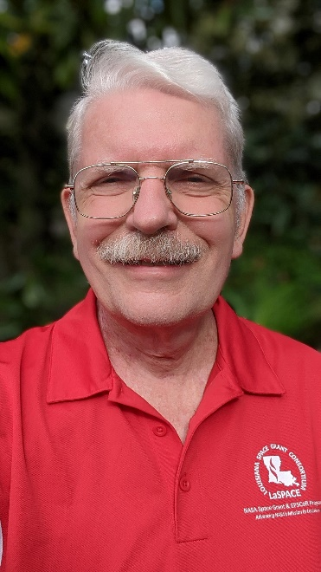
Greg Guzik, LSU Professor and Director of the Louisiana NASA Space Grant and EPSCoR Programs, is the recipient of the 2020 NASA Outstanding Public Leadership Medal.
Winter 2007, Long-Duration Scientific Ballooning Mission in Antarctica
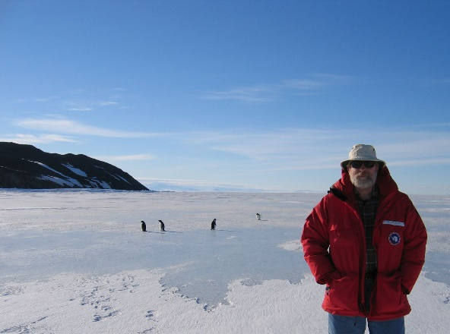
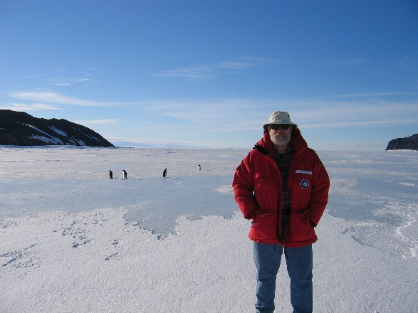
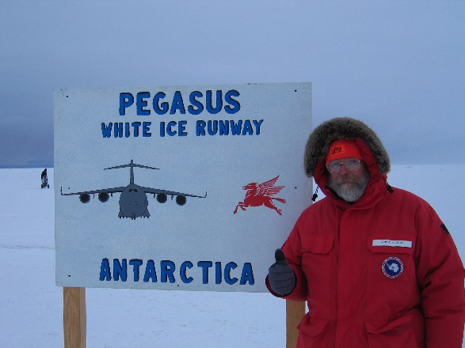
Greg Guzik is pictured here during his last long-duration scientific ballooning expedition in Antarctica in the winter of 2007 as part of the Advanced Thin Ionization Calorimeter (ATIC) research project.

May 2018, LaSPACE LaACES Launch trip to Columbia Scientific Balloon Facility in Palestine, TX:
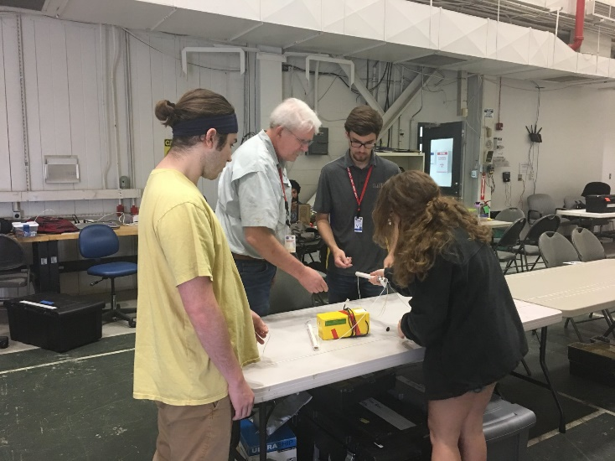
Guzik assists the LSU LaACES team with their payload.
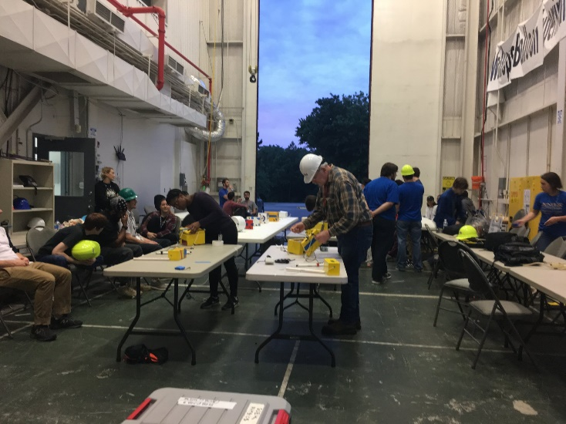
Guzik makes final checks of payloads on the flight string at dawn just before launch.

April 2019, LaACES Thermal/Vac Flight Readiness Tests for all Louisiana Teams Planning to Fly at CSBF in May 2019:
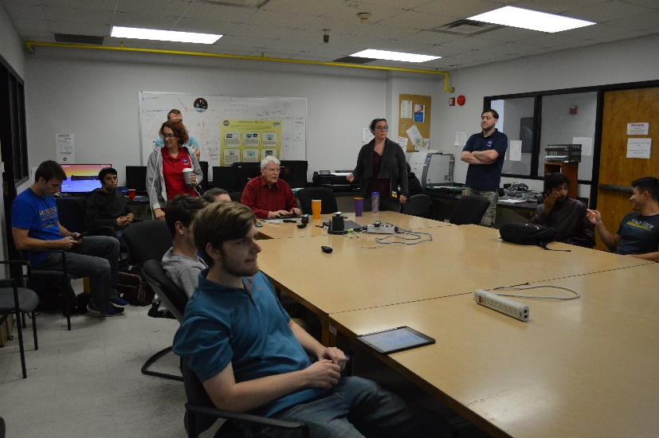
2019 LaACES Teams prepare to present the Thermal/Vac test results for their payloads.
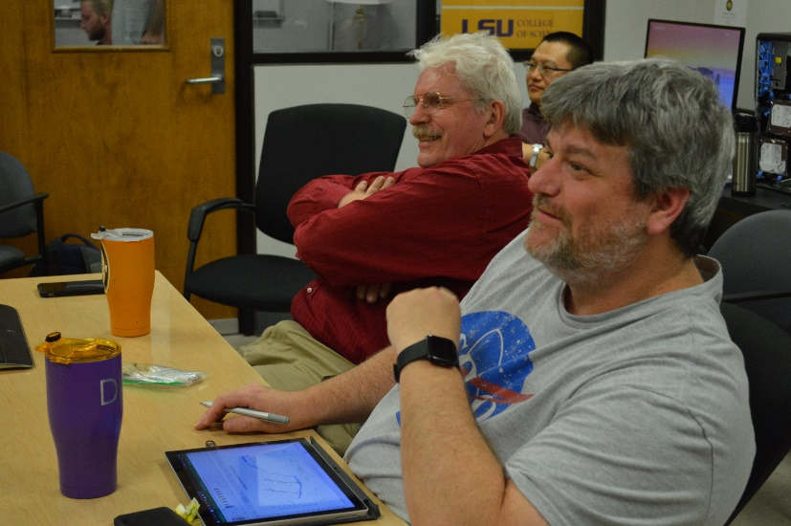
Guzik and LaSPACE Flight Program Manager, Doug Granger, enjoying the 2019 Thermal/Vac Tests
HASP Launch Trips to NASA Flight Facility in Ft. Sumner, New Mexico during 2018 & 2019:
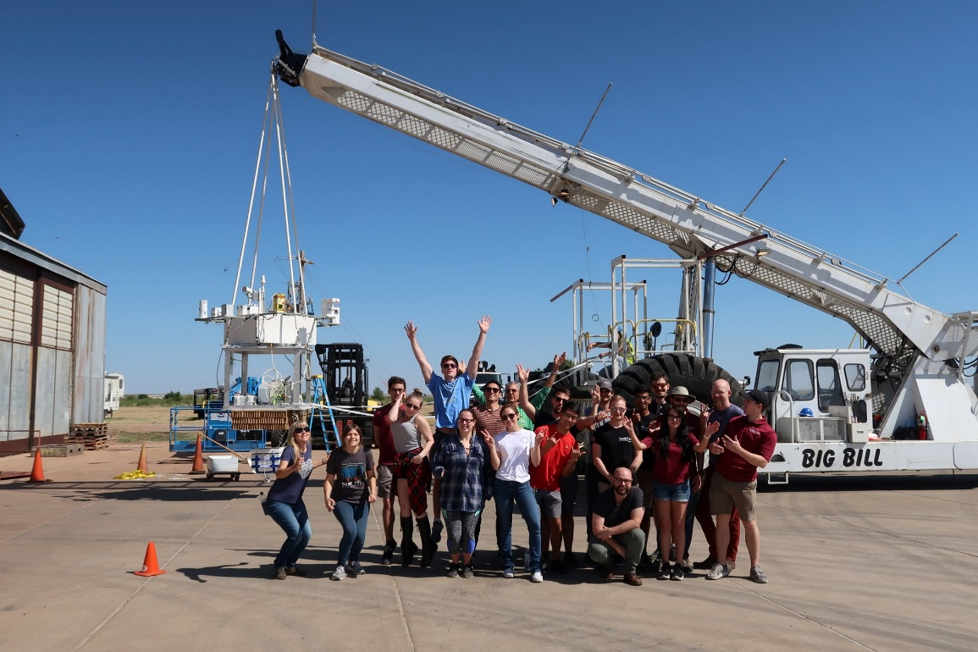
HASP Hang Test with student participants at Ft. Sumner on September 1, 2019.

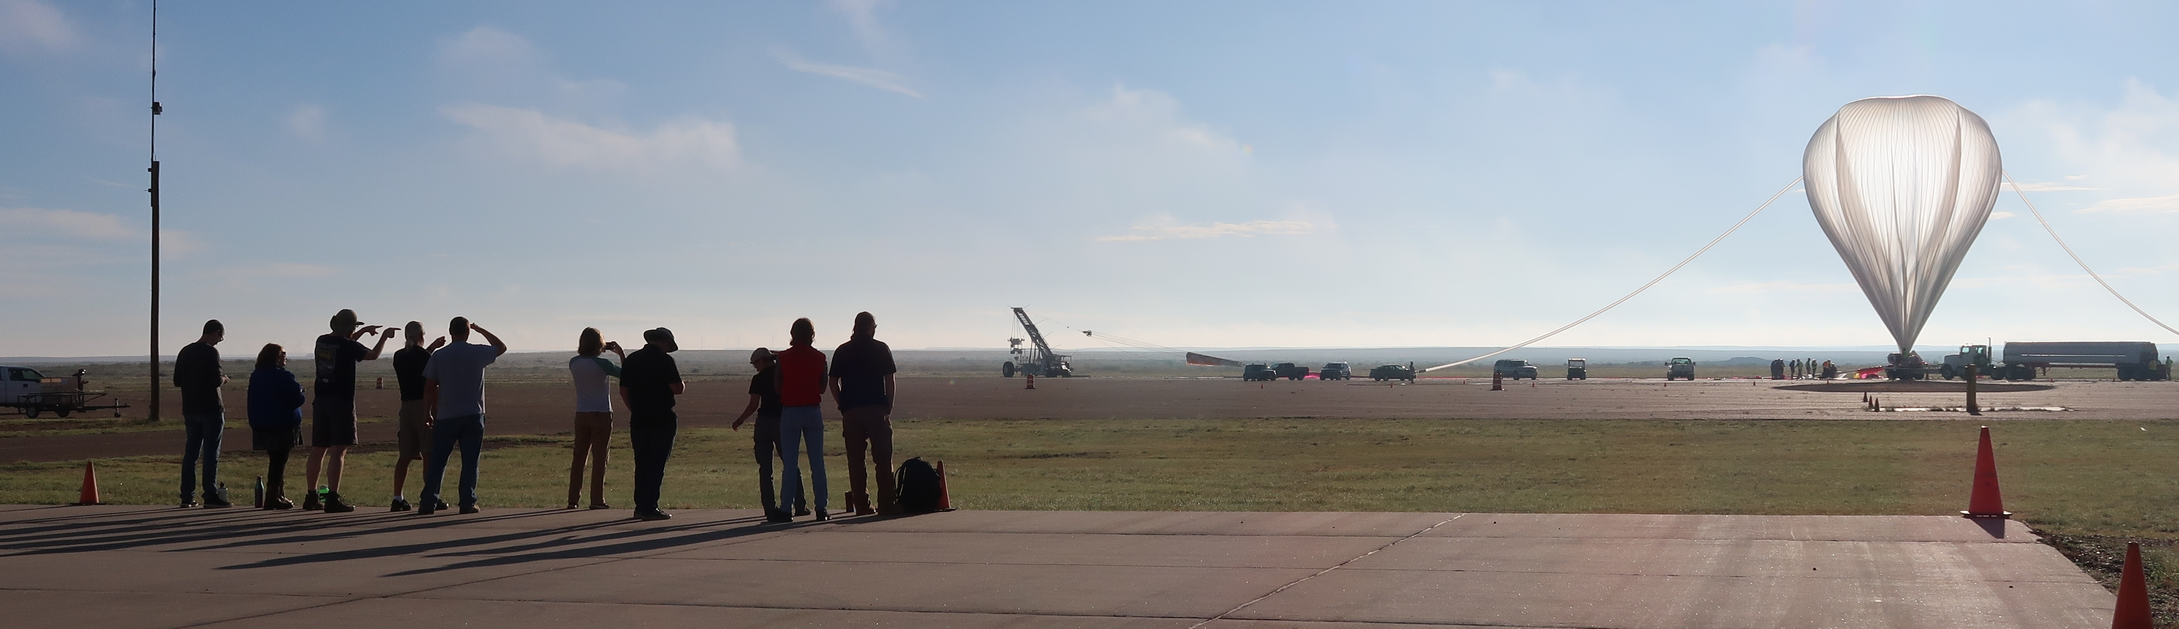
University students look on during the launch of their experiments as carried by the High Altitude Student Platform (HASP) balloon gondola in September 2018

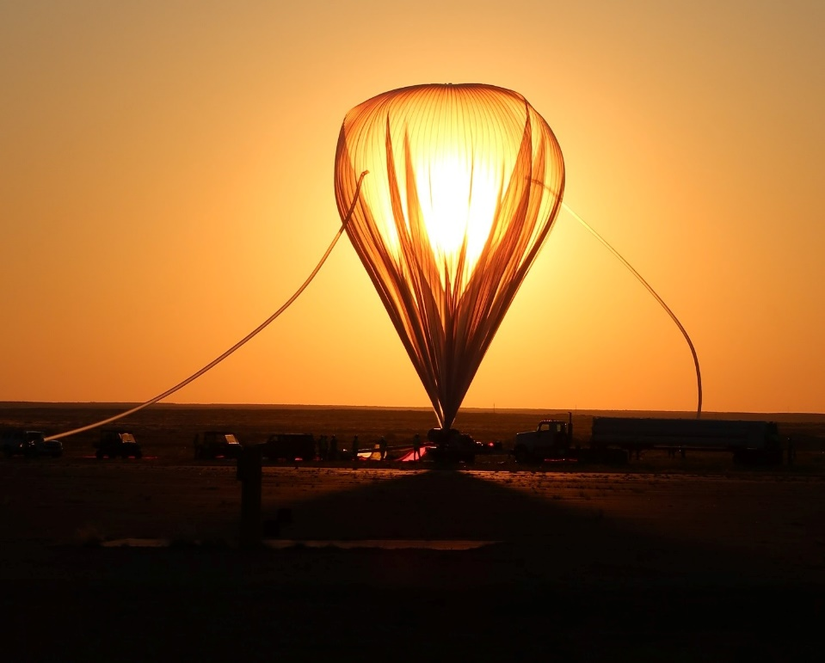
HASP preparing to launch at dawn on September 5, 2019.

