University of Colorado at Boulder June Status Report
In the month of June, members of HELIOS III continued to work within their sub-systems and began to integrate with other sub-systems. Nearly all components have been ordered and received and the structure is in the process of being built.
Team Demographics:
Cooper Benson: Caucasian male, sophomore, Aerospace Engineering
Paige Arthur: Caucasian female, sophomore, Aerospace Engineering
Kristen Hanslik: Caucasian female, sophomore, Aerospace Engineering
Chris Bradford: Caucasian male, sophomore, Aerospace Engineering
Dylan Richards: Caucasian male, sophomore, Aerospace Engineering
Tyler Lugger: Caucasian male, sophomore, Aerospace Engineering
Ryan Cutter: Caucasian male, sophomore, Aerospace Engineering
Alec Fiala: Caucasian male, sophomore, Aerospace Engineering
Ryan Tabler: Asian / Caucasian male, sophomore, Electrical and Computer Engineering
Jorge Cervantes: Hispanic male, junior, Aerospace Engineering
Brandon Boiko: Asian / Caucasian male, junior, Mechanical Engineering

Team Organizational Chart: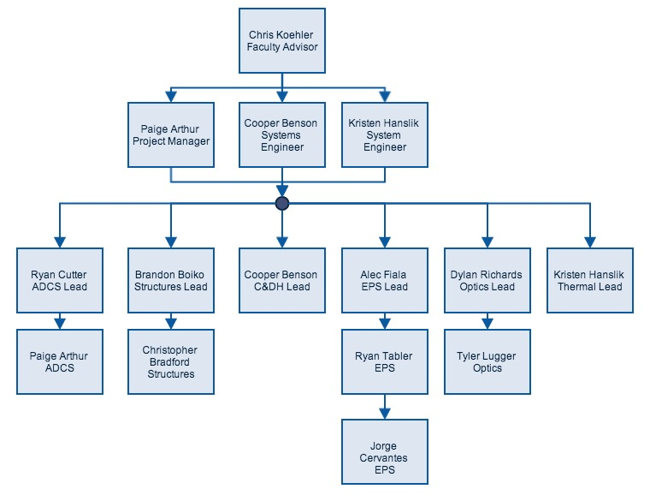

Accomplishments of May:
ADCS: The Attitude Determination and Control System has been working on creating and using circuit boards for their photodiode system. They selected new photodiodes with a better temperature range and new ADCs that use fewer pins. Much of the month was spent trying to solve a communication problem between the ADCs and the microcontroller. Once that problem was solved, ADCS has been experimenting with the best way to code the motor response to be fast, smooth, and accurate using a moving average and a model created by photodiode readings and ADCS camera images. They have also chosen filters for their photodiodes and will order them as soon as possible.
C&DH: Command and Data Handling has worked closely with ADCS to solve their communication problems and help create their circuit boards. They have finished setting up threading between six different pieces of code and have completed the uplink and downlink code. They have finished and tested the communication code. As soon as they test the Gertduino’s communication with the Raspberry Pi through the main circuit board they will have completed all of their assigned tasks and will focus on assisting other subsystems for the remainder of the process.
EPS: The Electrical and Power System has tested the first rev of the main circuit board, made changes to and purchased a second rev, attached components to the second rev, and is currently in the process of testing. They changed their choice of buck convertors to a more efficient one and confirmed the functionality of their sensors. They also tested the current sensors, determined that they needed different ones, and are currently waiting for them to arrive. They are also in the process of redesigning their board for a third and final rev.
Optics: Optics has received all of their parts, including the science camera, ADCS camera, filter, and telescope. They have been working with the systems engineer and their mentor to test all of their components. Recently they have taken images of the sun with the science camera and have determined that although the field of view is slightly smaller than they expected, the camera will be able to take very high quality images of the sun. Within the next few days they will test the ADCS camera in the same manner. They have been working closely with the structures sub-team to determine the necessary size of the camera housing.
Structures: Structures has worked on finalizing their SolidWorks and determining the best parts to be used. They finished designing the photodiode housing and are in the process of machining the structure out of aluminum. They have cut pieces for most of the base plate and are are working closely with Optics to determine the final dimensions of the camera housing. They have also been working closely with the systems engineers to find a solution to the problem of the payload being too tall.
Thermal: Thermal has been working with the Structures mentor, Mr. Lee Sutherland, to determine how to minimize the heat in the payload. They have been using equations to calculate the heat transfer in the payload to determine how thick the baseplate should be to act as an efficient heat sink. They now plan to use sil-pads to heat sink the payload’s most heat sensitive components. They looked into using a sil-pad under the baseplate, but because the baseplate will be in very little contact with the platform, they have rejected that idea.
Management: Management has worked with each of the sub-teams to ensure that they have the resources they need to complete their goals. They have set meetings with mentors and with older students in Space Grant to help the teams with obstacles, such as ADCS’s problem with communication with the photodiodes. They have kept track of the budget and determined what parts were necessary and what parts needed to be sacrificed. They have also worked with Structures, Optics, and ADCS to try to solve the problem of the payload being too tall and wide. Finally, they worked to completed the final version of the PSIP.

Plan for July:
HELIOS III hopes to be done and integrated with each individual sub-team by the middle of July so that we can test the entire payload. Our first priority is to determine the final dimensions of the structure so that the Structures team can finish machining and give the ADCS team something with which to test their motors and tracking system. EPS will be working to finish the final rev of the main PCB board. Optics will test the ADCS camera. ADCS is working on making the motors’ motion smoother and on running the system with all the code fully functional.

