HASP 2014

UND-UNF Payload

Monthly Status Report for June 2014

UNF Team
Faculty Advisor:
Dr. Nirmal Patel
Email: npatel@unf.edu
Office Phone: 904-620-1670
Cell: 904-200-2855

Students Team
- Kenneth Emanuel (Electrical Engineering) (Team Leader)
Email: k.emanuel@unf.edu
unfhasp@gmail.com
Cell: 904-614-2117

- Brittany Nassau ( Physics-Electrical Engineering)
Email: Brittany.Nassau@gamil.com
N00435969@unf.edu
Cell: 904-495-1765

UND Team
Faculty Advisors:
Dr. Ron Fevig
Email: rfevig@aero.und.edu,
Phone: 701-777-2480

Consultant:
Jonathan Snarr (Space Studies)
Email: Jonathan.snarr@und.edu
Email: wade@speedhut.com
Cell: 485-851-3572

UND-UNF team did the following work during June 2014:

Input Current Analysis

Analysis of input current to the UNF HASP payload was performed using a Keithley 2700 Multimeter interfaced to National Instruments LabVIEW for graphical display and data logging. The input voltage from the DC power supply was set at 31 VDC. Fig.1 shows the near real time data output from LabVIEW.
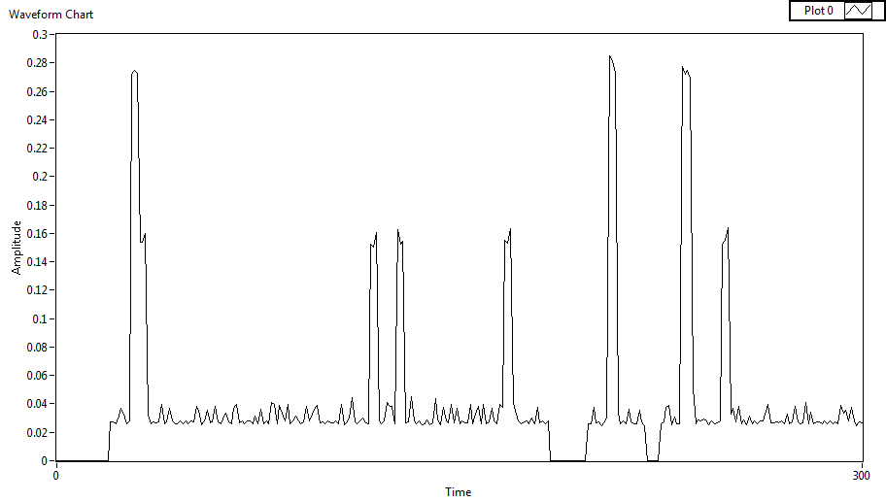
Fig.1 LabVIEW Output Data- Current (A) Amplitude vs Time (s)
Fig.2 shows the same data set for a 300 second duration where the UNF HASP Payload was power cycled 3 times during testing. The current is seen to be zero at each power cycle followed by current peaks at less than 0.3A (300 mA) which is well under the 0.5A maximum allowed current.

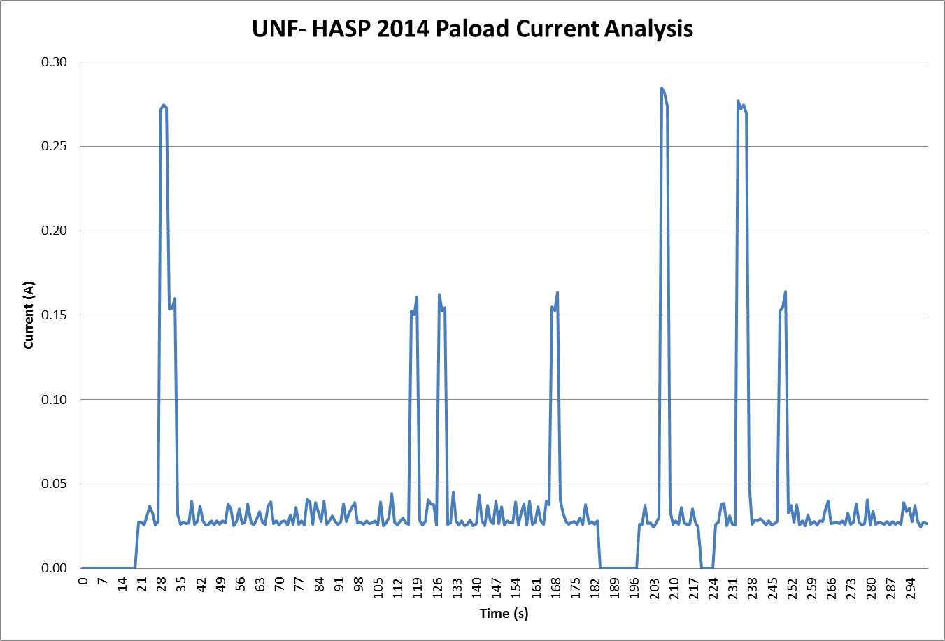
Fig.2 Input Current Analysis during power cycling

Fig.3 shows current data collected over 1000 second duration. Lower peaks indicate an average current of approximately 35 mA during normal operation in collection of data from gas sensors and other peripherals. Peaks of 165 mA show the current draw with two temperature control heaters in the on state during regulation. A fan was used to simulate a reduced temperature environment forcing all three heaters to the on state during which a maximum current draw of approximately 285 mA was observed.

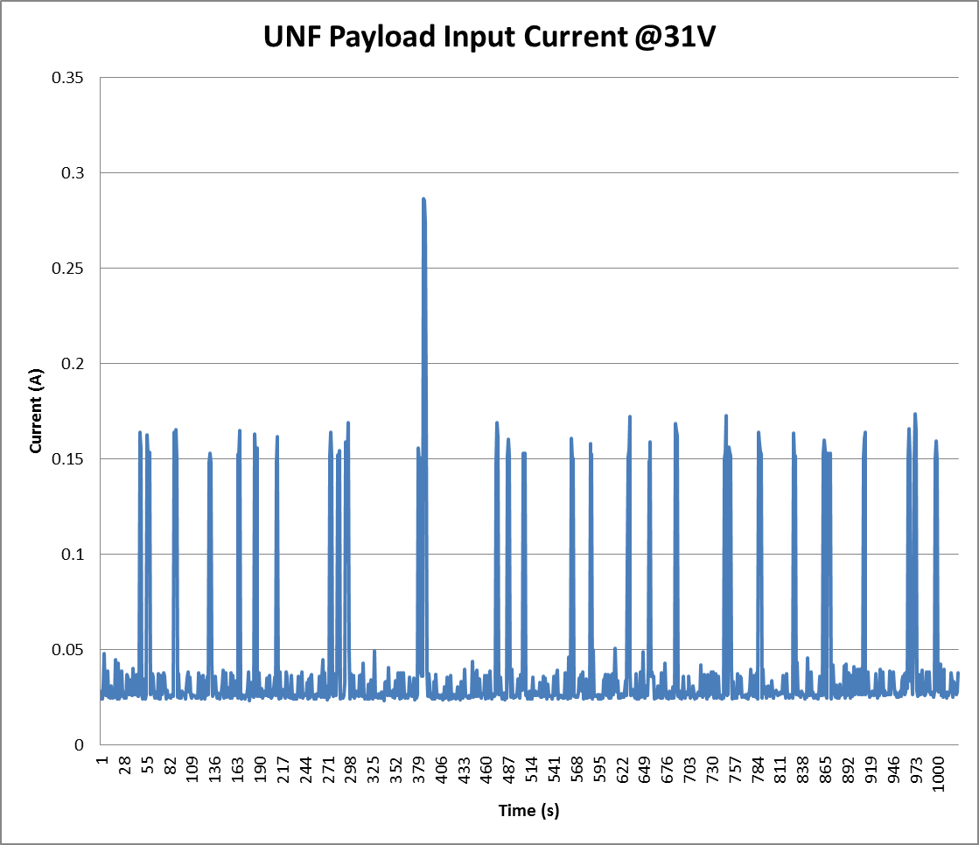
Fig.3 Input current analysis

Automated Data Collection and Analysis Software

In order to facilitate efficient data collection and analysis during integration, thermal vacuum testing and flight, automated data collection software is in development. The software will poll the HASP website for new files, retrieve the file, extract and filter data and lastly output the data to graphical charts for monitoring. Fig. 4 shows the block diagram for the software.

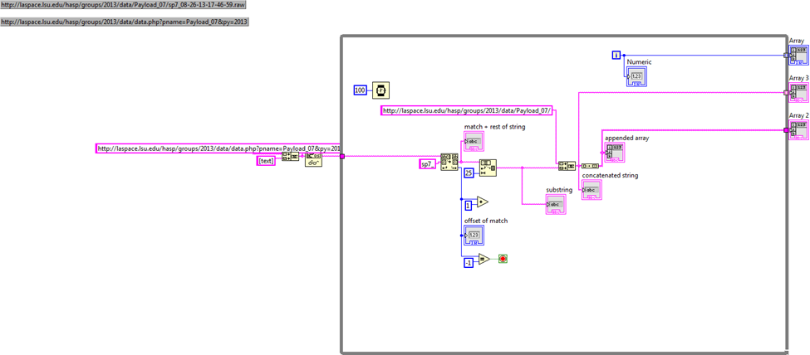
Fig.4 Block Diagram for Automated Data collection and analysis software
- Fabrication and testing of sensors are going on.
- UNF team jointly have participated the final round of RASC-AL competition organized by the NASA-NIA at the Hilton, Cocoa Beach during June 16-20, 2014.
- Preliminary Payload Specification and Integration Plan (PSIP) was corrected and revised as per the comments of Michael Stewart. The corrected file for PSIP is attached with this email.

