Payload Title: Sampling Microbes In The High atmosphere (SMITH)
Payload Class: Small Large (circle one)
Payload ID: P11
Institution: Louisiana State University A&M
Contact Name: Noelle Bryan
Contact Phone: 225-326-4628
Contact E-mail: nbryan5@tigers.lsu.edu
Submit Date: April 29, 2011
- Mechanical Specifications:
  - Measured weight of the payload (not including payload plate)

The payload is estimated to be 30lbs (~13.6Kg) based on the component weights and estimated housing weight. Its center of mass will be near the center of the interface plate and the height will be below 6 inches of the plate itself. These are all estimates based on mechanical drawings and will be defined further as the payload is developed.

  - Provide a mechanical drawing detailing the major components of your payload and specifically how your payload is attached to the payload mounting plate

The payload will be mounted to the interface plate with 4 ¼” screws. Their positions are shown in Figure 1 below. The overall outline of the payload is shown as well and is completely contained in within the keep out line.
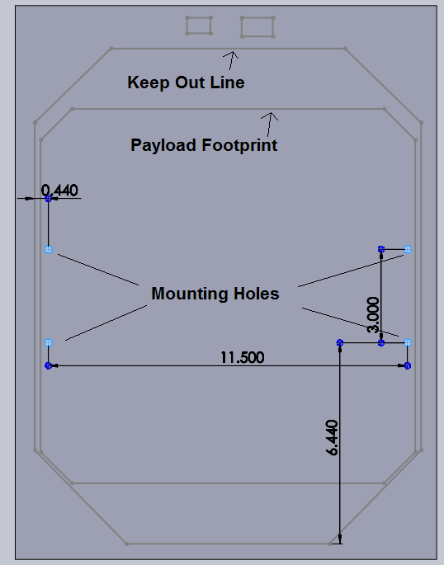
Figure 1

The payload will consist of 2 DC motors, 2 model airplane engines, 4 solenoid valves, 2 filters, and the electronics. Everything except the electronics will be mounted on the lower half of the payload and is shown in Figure 2. The side panels will detach from the frame to allow easy access to the inside when assembling and bolting to the interface plate. They are then reattached and the whole system will be fully assembled before the interface plate is attached to HASP. The frame itself as well as the component mounting plates will be made completely of aluminum. The electronics will be attached above the frame shown in Figure 3 and will be contained within their own housing. This housing will be aluminum that is insulated on the inside to maintain the temperature of the electronics while still providing protection. The entire footprint is 12 x 12 inches and will be less than 12 inches tall.
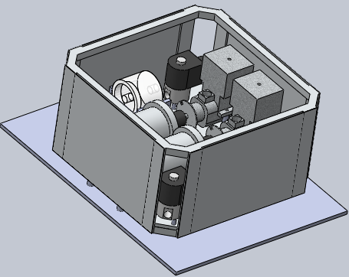
Figure 2

  - If you are flying anything that is potentially hazardous to HASP or the ground crew before or after launch, please supply all documentation provided with the hazardous components (i.e. pressurized containers, radioactive material, projectiles, rockets…)
No Hazardous Material
  - Other relevant mechanical information
No other relevant mechanical information

- Power Specifications:
  - Calculated current draw by each component

Type of DC/DC Converter | Efficiency (%)
30 V-12 V (Converters 1) | 94
30 V-12 V (Converters 2) | 85
30 V-3.3V | 83

Table 1: Current drawn by each component
Part Number | Voltage | Current (mA) | Duty Cycle (%) | Power (W)
30-12 V DC/DC Converter 1 | 30 | 188 | 100 | 5.64
30-12 V DC/DC Converter 2 | 30 | 1882.35 | 100 | 8.47
30-3.3 V DC/DC Converter | 3.3 | 0.396 | 100 | 0.0048
MAX 3107 Chip 1 | 3.3 | 1.3 | 100 | 0.00429
MAX 3107 Chip 2 | 3.3 | 1.3 | 100 | 0.00429
MAX 3232 | 3.3 | 1 | 100 | 0.0033
PCA9514A | 5 | 6 | 100 | 0.03
PCF8583 | 5 | 50 | 100 | 0.25
HOA088X | 5 | 80 | 100 | 0.4
BalloonSat | 12 | 55 | 100 | 0.66
DC Motor 1 | 12 | 4000 | 99.9 | 47.95
DC Motor 2 | 12 | 4000 | .1 | 0.048
Intake Valve 1 | 12 | 190 | 100 | 2.5
Intake Valve 2 | 12 | 190 | 100 | 2.5
Outtake Valve 1 | 12 | 190 | 0.1 | 0.00228
Outtake Valve 2 | 12 | 190 | 0.1 | 0.00228
Temperature Sensor 1 | 12 | 1 | 100 | 0.012
Temperature Sensor 2 | 12 | 1 | 100 | 0.012
Temperature Sensor 3 | 12 | 1 | 100 | 0.012
Temperature Sensor 4 | 12 | 1 | 100 | 0.012
Pressure Sensor 1 | 12 | 1.5 | 100 | 0.018
Pressure Sensor 2 | 12 | 1.5 | 100 | 0.018
Total |  |  |  | 68.55

  - HASP is providing power to SMITH. Figure 1 provide a power system wiring diagram starting from pins on the payload interface plate EDAC 516 connector through your power conversion to the voltages required by the subsystems.
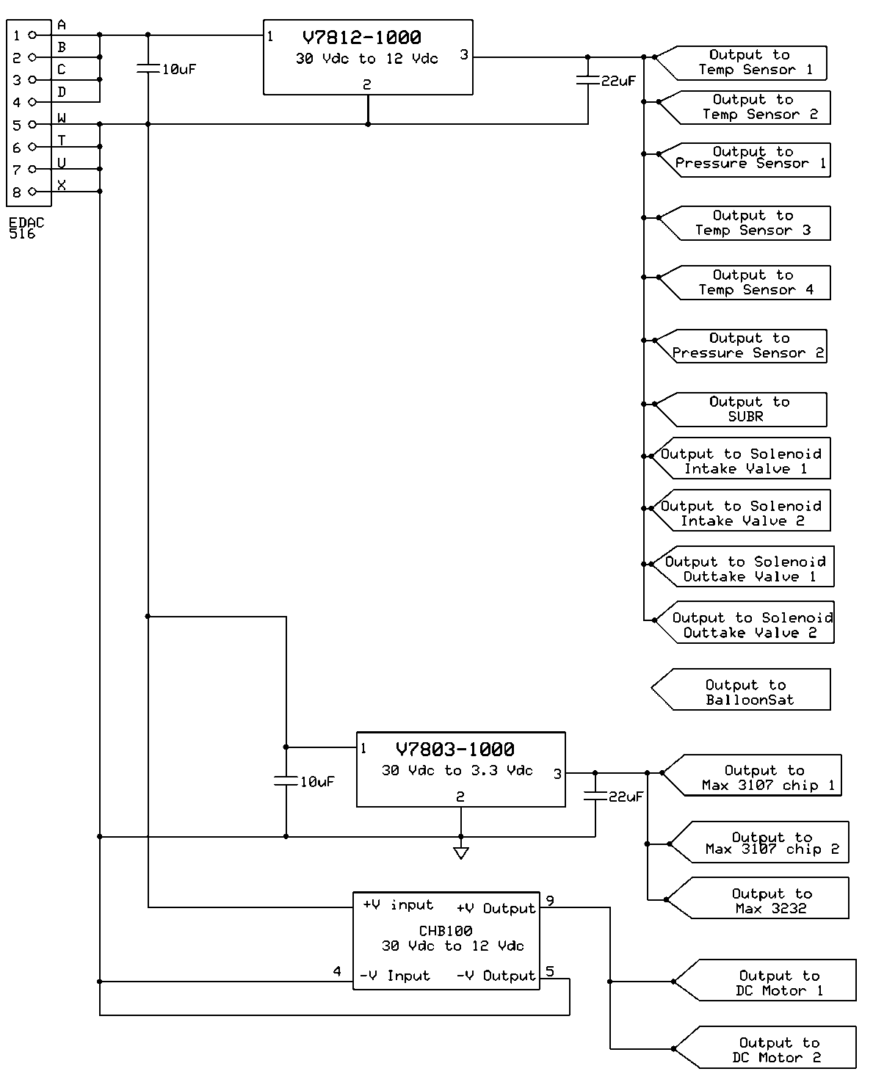
Figure 3: Power Subsystem

Table 2: EDAC Pin Assignment
Function | EDAC Pins | Wire Color | Connector Pins
+30 V_{DC} | A, B, C, D | White with Red Stripe | 1, 2, 3, 4
Power Ground | W, T, U, X | White with Black Stripe | 5, 6, 7, 8
  - Other relevant power information
No other relevant information
- Downlink Telemetry Specifications:
I. Downlink Telemetry Specifications:
A. Serial data downlink format: Stream Packetized (circle one)
B. Approximate serial downlink rate (in bits per second)
20 bps
C. Specify your serial data record including record length and information contained in each record byte.
Table 3: Record Format for Every 10 seconds
Record Format | Size (Bytes)
Label | 1
Real Time Clock – Day | 1
Real Time Clock – hour | 1
Real Time Clock – Minute | 1
Real Time Clock – Second | 1
Sample pump temp sensor | 1
Sample motor temp sensor | 1
Sample pressure sensor | 1
Sample intake sensor | 1
Sample exhaust sensor | 1
Sample RPM counter HIGH byte | 1
Sample RPM counter LOW byte | 1
Sample State:  - Intake valve  - Exhaust valve  - pump | ½ byte
Control pump temp sensor | 1
Control motor temp sensor | 1
Control pressure sensor | 1
Control intake sensor | 1
Control exhaust sensor | 1
Control RPM counter HIGH byte | 1
Control RPM counter LOW byte | 1
Control State:  - Intake valve  - Exhaust valve  - pump | ½ byte
Total: | 20
Table 4: Record Format for every 1 minute
Record Format | Size (Bytes)
Label | 1
Real Time Clock – Day | 1
Real Time Clock – hour | 1
Real Time Clock – Minute | 1
Real Time Clock – Second | 1
Environmental temp sensor | 1
Environmental pressure sensor | 1
Environmental humidity sensor | 1
Total: | 8

D. Number of analog channels being used:
None will be used.
E. If analog channels are being used, what are they being used for?
None will be used.
F. Number of discrete lines being used:
None will be used.
G. If discrete lines are being used what are they being used for?
None will be used.
H. Are there any on-board transmitters? If so, list the frequencies being used and the transmitted power.
None will be used.
I. Other relevant downlink telemetry information.
IV. Uplink Commanding Specifications:
A. Command uplink capability required: Yes No (circle one)
B. If so, will commands be uplinked in regular intervals: Yes No (circle one)

C. How many commands do you expect to uplink during the flight (can be an absolute number or a rate, i.e. n commands per hour)
Two commands are expected to be uplinked during the flight. However, we have the options to uplink more for manual controls.
D. Provide a table of all of the commands that you will be up-linking to your payload

Table 5: Up-link Commands
List of commands for sampling chamber:
- Open Intake Valve
- Close Intake Valve
- Open Exhaust Valve
- Close Exhaust Valve
- Turn on pump
- Turn off pump
- Begin sampling
- Stop sampling
List of commands for control chamber:
- Open Intake Valve
- Close Intake Valve
- Open Exhaust Valve
- Close Exhaust Valve
- Turn on pump
- Turn off pump
- Begin sampling
- Stop sampling

E. Are there any on-board receivers? If so, list the frequencies being used.
None will be used.
F. Other relevant uplink commanding information.
- Integration and Logistics
  - Date and Time of your arrival for integration:
The integration team will arrive on the afternoon of Sunday July 31, 2011.
  - Approximate amount of time required for integration:
To Be Decided
  - Name of the integration team leader:
Noelle Bryan
  - Email address of the integration team leader:
nbryan5@tigers.lsu.edu
  - List ALL integration participants (first and last names) who will be present for integration with their email addresses:
Noelle Bryan
Allen Bordelon
  - Define a successful integration of your payload:
Payload is bolted down on the HASP plate.
Payload is receiving power from HASP EDAC connecter.
Payload is sending and receiving commands from the ground command.
Sample chamber is connected to the main payload and remains sealed until commanded to begin sampling.

  - List all expected integration steps:
      - Attach sample chamber to main payload
      - Power verification
      - Communication verification
      - Begin sampling procedures
      - Turn on pump
      - Verify pump functioning at various pressures and temperatures
      - Turn off pump
      - Close valves in proper order
      - Remove sample chamber
      - Verify sample chamber remains sealed
      - Power down

