Payload Title: TigreSAT Payload
Payload Class (Small / Large): small Flight Number: 2011 Payload ID: 8

Institution: Inter-American University of Puerto Rico, Bayamón Campus

Contact Name: Javier I. Espinosa Acevedo

Contact Phone: 787 420 3877

Contact E-mail: J.23.espinosa.13@gmail.com

Submit Date: 08-01-2011

Flight-line Setup & Pre-launch Checkout Procedures:
- Mechanical Specifications:
  - Measured weight of the payload (not including payload plate)
The payload has a measured weight of 1080g not including the platform plate and 1380 with the plate
Provide a mechanical drawing detailing the major components of your payload and specify how your payload is attached to the payload mounting plate.

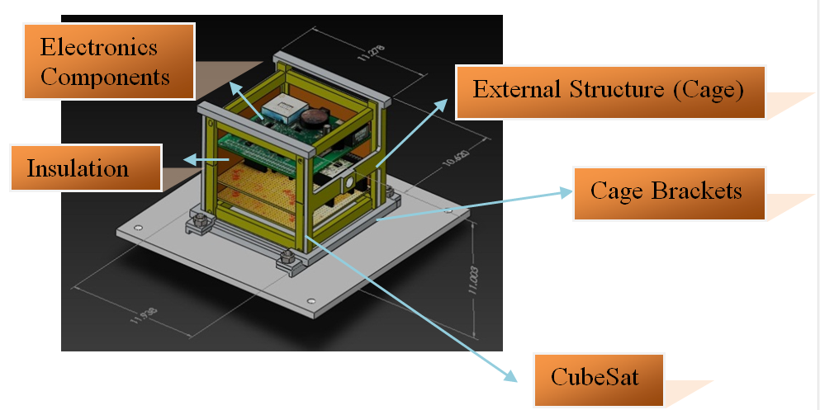
Figure 1: CAD drawing and photo of how the payload is attached to the plate

Figures 1 is a mechanical drawing of how the structure is attached to the HASP plate. The hinges is part of the cage, the 4 bolts with hinges will be place on the bottom side to maintain the structure in a fixed position.

  - If you are flying anything that is potentially hazardous to HASP or the ground crew before or after launch, please supply all documentation provided with the hazardous components (i.e. pressurized containers, radioactive material, projectiles, rockets…)

The CubeSat TigreSAT payload will not fly anything that is potentially hazard to the HASP balloon and neither to the ground crew before and after launch.

Other relevant mechanical information
N/A
- Power Specifications:
  - Measured current draw at 30 VDC
The total current that the CubeSat TigreSAT prototype draws is currently approx. 225mA.
  - If HASP is providing power to your payload, provide a power system wiring diagram starting from pins on the student payload interface plate EDAC 516 connector through your power conversion to the voltages required by your subsystems.
Figure 5: Power Diagram

In the Figure 5 shows how the power is obtained from the HASP platform throughout the EDAC connector. The wires A, B, C, D are connected together for the positive 30V and wires W, T, U, V are connected together for the GND of the HASP platform, this
parallel connection is to obtain the 30V @ .5A which will be step down to 5V with an NDL4805 DC to DC converter to supply the 5V sensors and the UA78M33DC 3.3V voltage regulator to supply the 3.3V according sensors. An LED is placed in the 3.3V regulator to allow a visual verification of functionality.

  - Other relevant power information
The CubeSat TigreSAT prototype will have a total of five (5) solar panels that will be characterized to obtain maximum performance, but this system will be not connected to HASP.
- Downlink Telemetry Specifications:
  - Serial data downlink format: stream
  - Approximate serial downlink rate:
The Approximate serial downlink rate will be 14 bytes per second and known as
14bytes x8bit/bytes = 112bits per second.

Specify your serial data record including record length and information contained in each record byte.

The total bytes required for the flight is determined by the quantity of the sensors and the total bytes of the measurement of the sensor times the hours the payload may remain in flight.

The system has four sensors; three axis magnetometer, three axis gyroscope, three axis accelerometer, an internal temperature sensor and a GPS receiver. Each sensor with three axes will have a total of 15 bytes (5 bytes per axis) and the internal temperature sensor will have a total of 7 bytes. The time stamp consists of 17 bytes, two bytes for the hours, two bytes for the minutes, two bytes for the seconds, two bytes for the months, two bytes for the days, two bytes for the years and 5 bytes for the time and date separators. The GPS will consist of 16 bytes. 12 more bytes will be used in comma separators. One last byte is used for the end of file. In total we have 99 bytes. The sample rate will be of approximately 7 second.
01_13:16:28,-1335,-1415,-2844,-1197,-1288,-1390,-1208,-1332,-1262,-124.81,06/01/2011,13:16:28\n

Byte | Description
1-17 | Time Stamp
18 | Comma Separator
19-23 | Accelerometer: X axis
24 | Comma Separator
25-29 | Accelerometer: Y axis
30 | Comma Separator
31-35 | Accelerometer: Z axis
36 | Comma Separator
37-41 | Gyroscope: X axis
42 | Comma Separator
43-47 | Gyroscope: Y axis
48 | Comma Separator
49-53 | Gyroscope: Z axis
54 | Comma Separator
55-59 | Magnetometer: X axis
60 | Comma Separator
61-65 | Magnetometer: Y axis
67 | Comma Separator
68-72 | Magnetometer: Z axis
73 | Comma Separator
74-80 | Internal Temperature Sensor
81 | Comma Separator
82-89 | GPS Date
90 | Comma Separator
91-98 | GPS Time
99 | End of Line

1: Serial Data Record per second

The data will be saved in the SD card. The SD card will be formatted FAT 16 before use. The program will use the SDFat library to create an object to access Fat16 files in SD cards. The data will be saved as a comma separated values (CSV) format.
  - Number of analog channels being used:
There will be no analog channels used
  - If analog channels are being used, what are they being used for?
N/A
  - Number of discrete lines being used:
N/A
  - If discrete lines are being used what are they being used for?
N/A
  - Are there any on-board transmitters? If so, list the frequencies being used and the transmitted power.
No, the TigreSAT will not have an on board transmitter.
  - Other relevant downlink telemetry information.
No

- Uplink Commanding Specifications:
  - Command uplink capability required: Yes No (circle one)
Yes, The CubeSat TIGRESAT prototype will have uplink capability.
  - If so, will commands be uplinked in regular intervals: Yes No (circle one)
  - How many commands do you expect to uplink during the flight (can be an absolute number or a rate, i.e. n commands per hour)
We expect to uplink a few times (around 10 uplinks) throughout the flight, no more than 4 commands in one hour.
  - Provide a table of all of the commands that you will be up linking to your payload

A. Uplink Command List: This list should contain all of the commands for your payload.

- Wake Up Command:
Command Name: | ON
Hex Command Byte: | 4F
Description: | Wakes up the payload from sleep
Critical? | Yes
Payload Response Message: | "Command Received: ON"

- Sleep Command:
Command Name: | OFF
Hex Command Byte: | 46
Description: | Puts the payload on sleep mode
Critical? | Yes
Payload Response Message: | "Command Received: OFF"

- Gumstix On Command:
Command Name: | TON
Hex Command Byte: | 54
Description: | Turns on the gumstix
Critical? | Yes
Payload Response Message: | "Command Received: TON"

- Gumstix Off Command:
Command Name: | TOFF
Hex Command Byte: | 4E
Description: | Turns off the gumstix
Critical? | No
Payload Response Message: | "Command Received: TOFF"

- Heater On Command:
Command Name: | HON
Hex Command Byte: | 48
Description: | Turns on the heater
Critical? | No
Payload Response Message: | "Command Received: HON"

- Heater Off Command:
Command Name: | HOFF
Hex Command Byte: | 68
Description: | Turns off the heater
Critical? | No
Payload Response Message: | "Command Received: HOFF"

- NULL Command:
Command Name: | NULL
Hex Command Byte: | 00
Description: | Terminates listening mode
Critical? | No
Payload Response Message: | "Unrecognized or NULL command"

Example of Command Transmission String
Here is an example of the TON command string in hexadecimal format:
“01028054030D0A”

Byte | Hex Value | Description
1 | 01 | Start of Heading (SOH)
2 | 02 | Start of Text (STX)
3 | 80 | Payload ID + Checksum
4 | 54 | Hex Command Byte
5 | 03 | End of Text (ETX)
6 | 0D | Carriage Return (CR)
7 | 0A | Line Feed (LF)

Are there any on-board receivers? If so, list the frequencies being used.
Yes, a GPS receiver with a frequency of 1575.42MHz in the UHF band
  - Other relevant uplink commanding information.
No
- Integration and Logistics
- Date and Time of your arrival for integration:
Arrival will be by August 1, 2011.
- Approximate amount of time required for integration:
The approximate amount of time required for the integration of the TigreSAT payload is no more than three hour
- Name of the integration team leader:
Javier I. Espinosa Acevedo
- Email address of the integration team leader:
J.23.espinosa.13@gmail.com
- List ALL integration participants (first and last names) who will be present for integration with their email addresses:
Name: Javier I Espinosa Acevedo
Email: J.23.espinosa.13@gmail.com
Additional participants TBD
- Define a successful integration of your payload:
A successful integration of the CubeSat TigreSAT payload will consist of a proper functional payload and retrieval of the data.
- List all expected integration steps:
The expected integration steps for the CubeSat TigreSAT payload are as follows;
- Place mounting plate with CubeSat TigreSAT payload plate on the HASP platform with proper nuts and bolts.
- Connect the HASP power cable to the EDAC power connector to the CubeSat TigreSAT payload platform.
- Connect the telemetry cable (DB9) to the to the payload platform.
- Verify that the LED on the board is ON following steps
- Payload’s CubeSat Verification procedure:
  - To remove the 4 screws payload’s CubeSat bracket you need to use a small Allen key (size 1.25mm), place it inside the screw hole and turn it counterclockwise until the screw is outside of the hole.

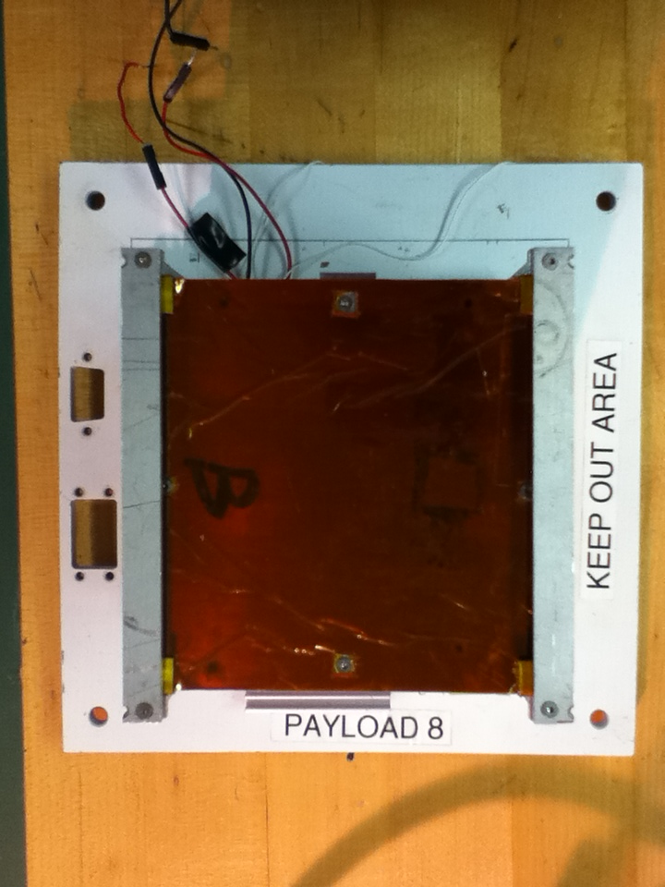
CubeSat
CubeSat Brackets
Screw 4
Screw 3
Screw 1
Screw 2
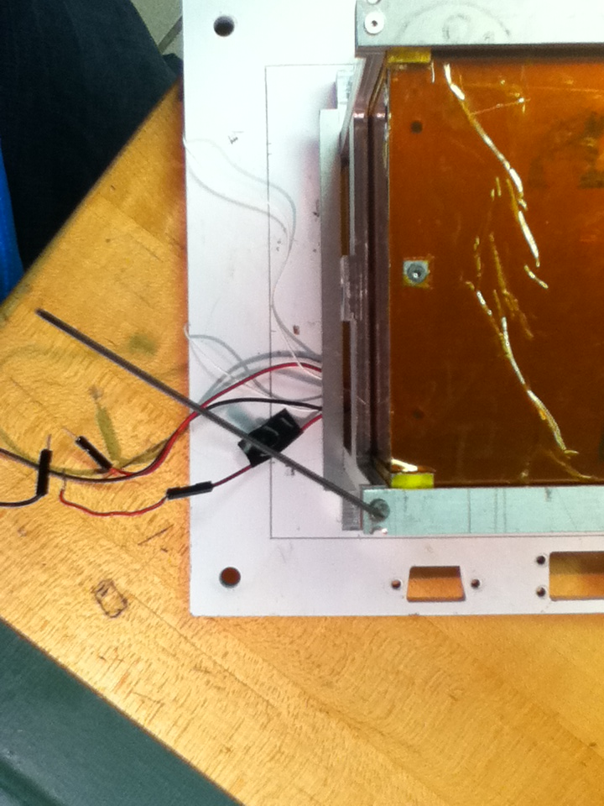
Screw
Allen Key

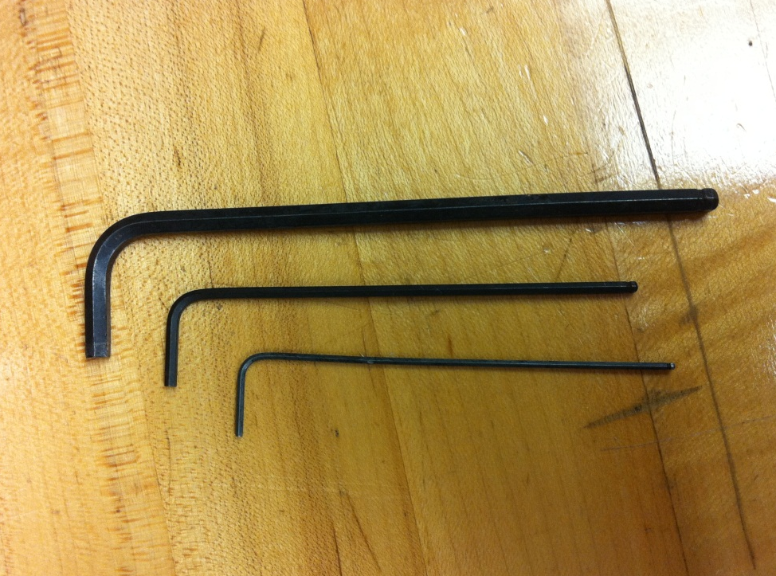
1.25mm Ball point Allen

1.58mm Ball point Allen

4mm Ball point Allen

- Remove the 4 bolts Cage bracket base with an Adjustable Wrench and turn it counterclockwise until the bolt is outside of the screw.

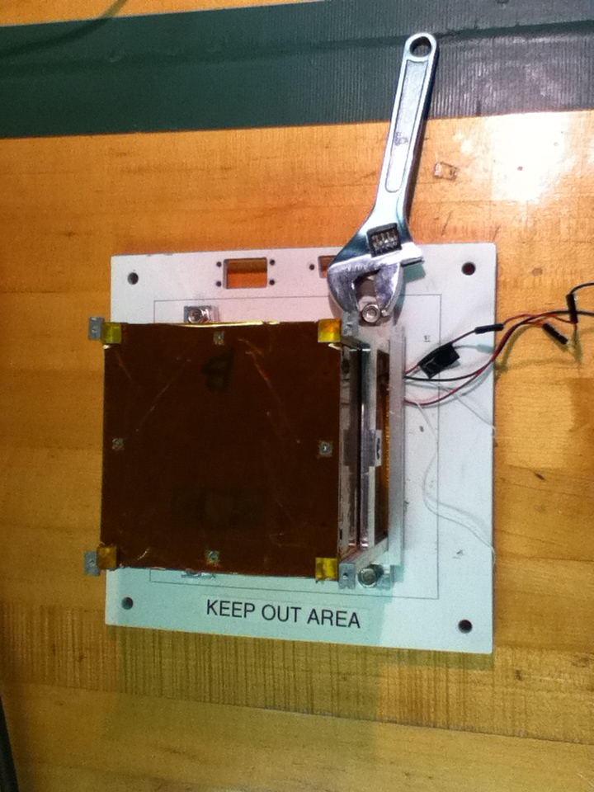
Bolt 3
Cage Bracket
Adjustable Wrench
Bolt 4
Bolt 2
Bolt 1
CubeSat Cage

- Remove the 2 cage brackets outside the base.

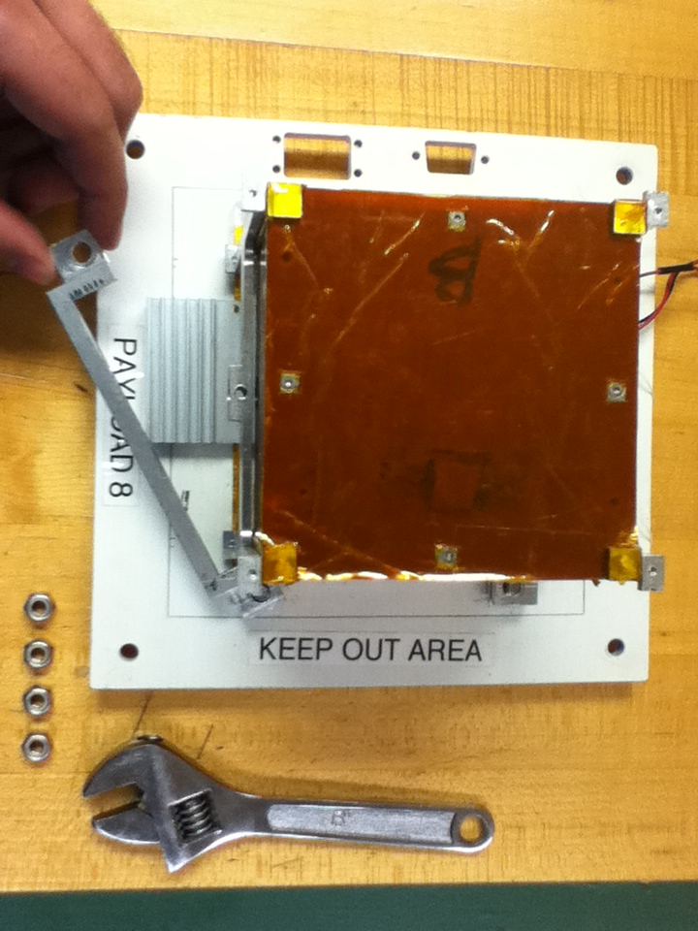
Bracket 1
Bracket 2

- Remove the cage with the CubeSat outside the base using your hands.
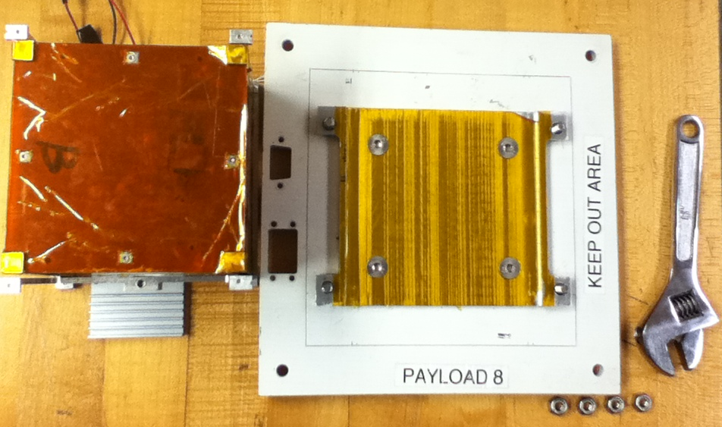
CubeSat Cage
Cage Base
CubeSat
- Remove the insulated foam at the bottom of the CubeSat using your hands.

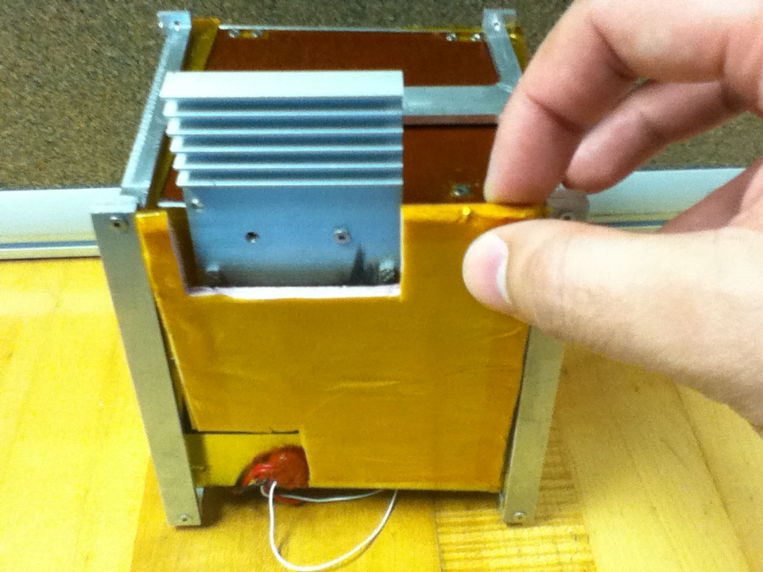
Insulated Foam

- To remove the screw to take out heat sink at the bottom of the CubeSat you need to use a small Allen key (size 1.25mm), place it inside the screw hole and turn it counterclockwise until the screw is outside of the hole.

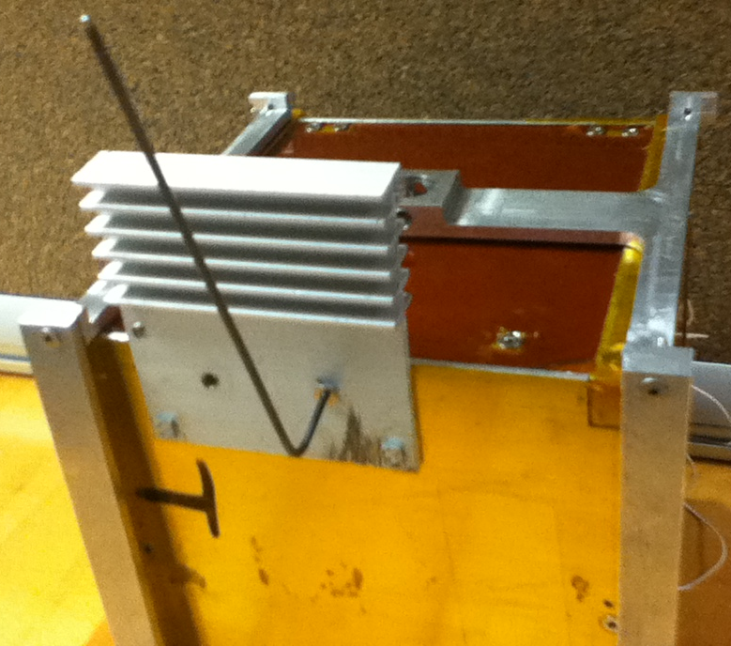
Heat Sink
Allen key

- Remove the CubeSat outside the Cage using your hands.

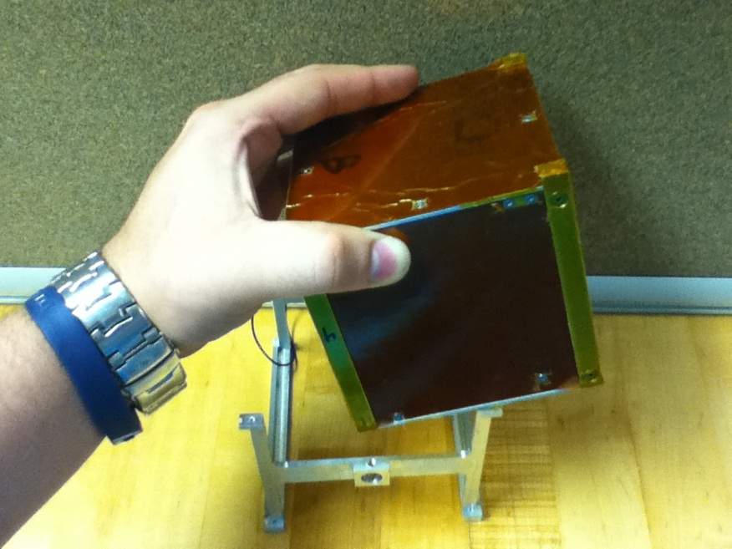
CubeSat
Cage

2. Verification of board’s functions

  - To remove 4 screws in the CubeSat Cap from the CubeSat frame you need to use a small Allen key (size 1.25mm), place it inside the screw hole and turn it counterclockwise until the screw is outside of the hole.
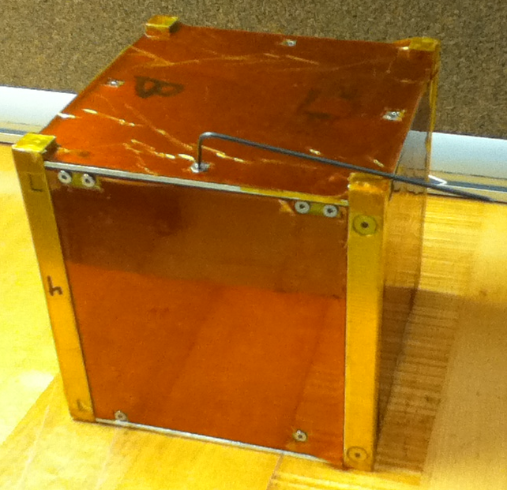
Frame
Allen Key
CubeSat Cap

- Remove the cap carefully without damage the internal components and the Kapton insulation by using your hands.
Cap covered with Kapton insulation
Frame

- To remove 6 screws in the CubeSat walls from the CubeSat frame you need to use a small Allen key (size 1.25mm), place it inside the screw hole and turn it counterclockwise until the screw is outside of the hole.
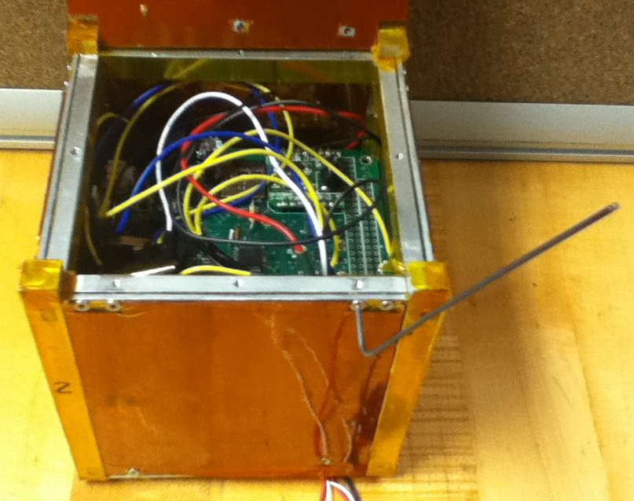
CubeSat wall
Frame
Allen Key

- Remove the 4 walls carefully without damage the internal components and the Kapton insulation using your hands.
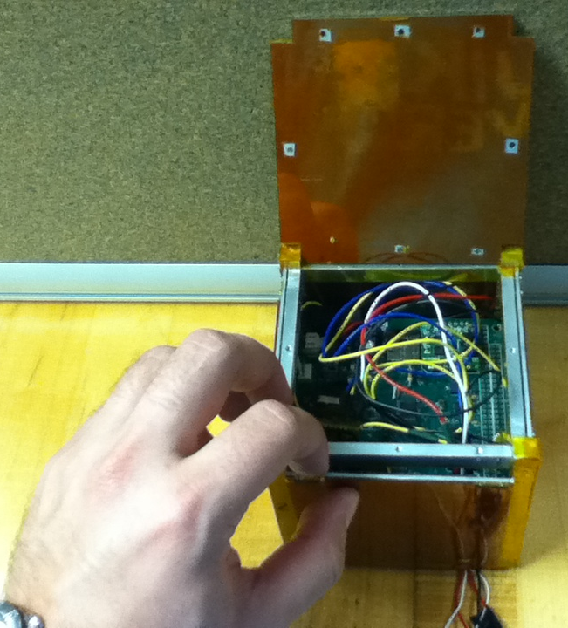
Wall 4
Wall 3
Wall 1
Wall 2

- The two Micro SD must be formatted before flight. Before removing the SD card from the board the board’s power connector has to be disconnected.

  - Be sure that the red light in top board is off

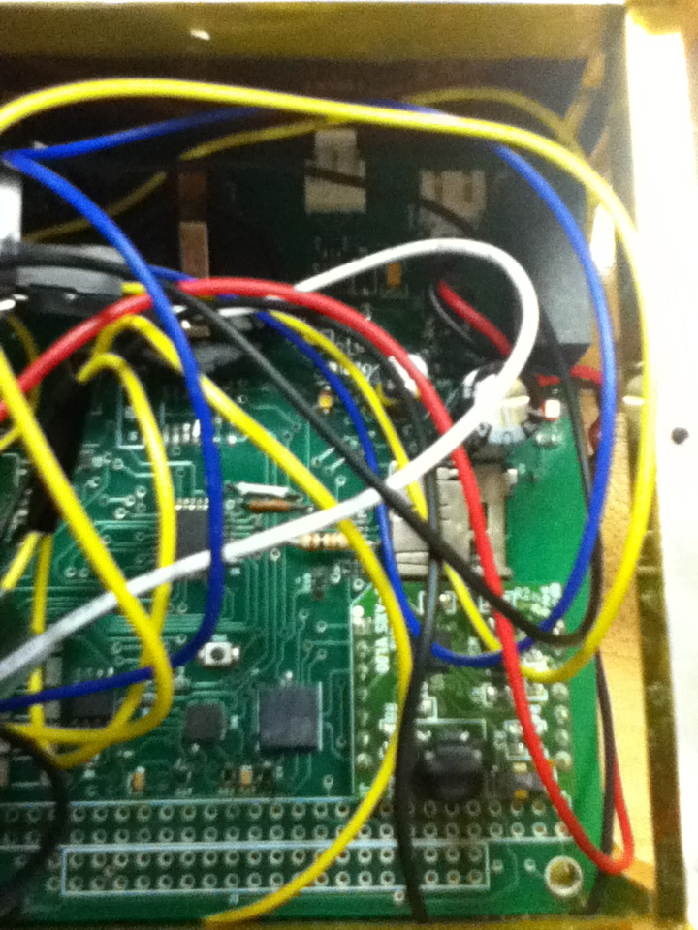
LED – red light

  - Removing first Micro SD Card carefully using your finger by pressing them.

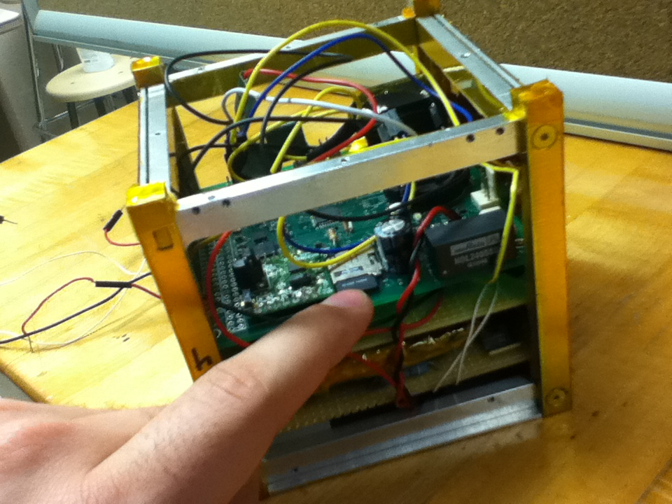
Micro SD Card

  - Removing the second Micro SD Card by pressing them with a clamp
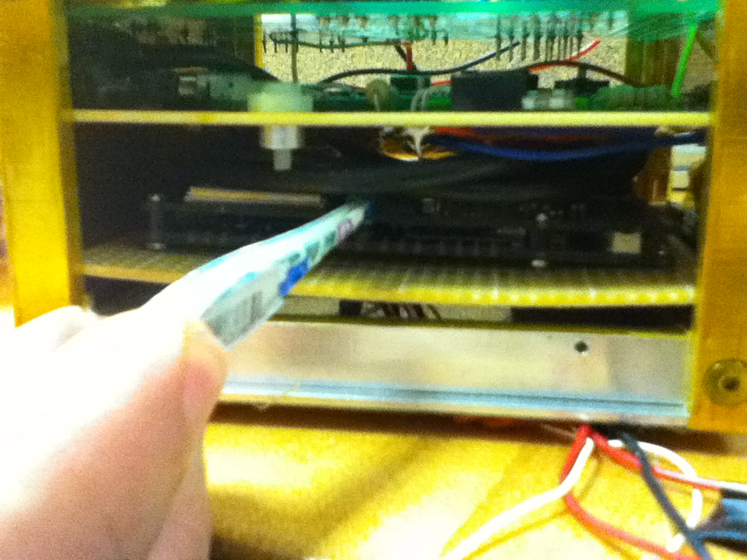
Micro SD Card
Clamp

  - Removing the second Micro SD card using the clamp after pressing them to take it out.

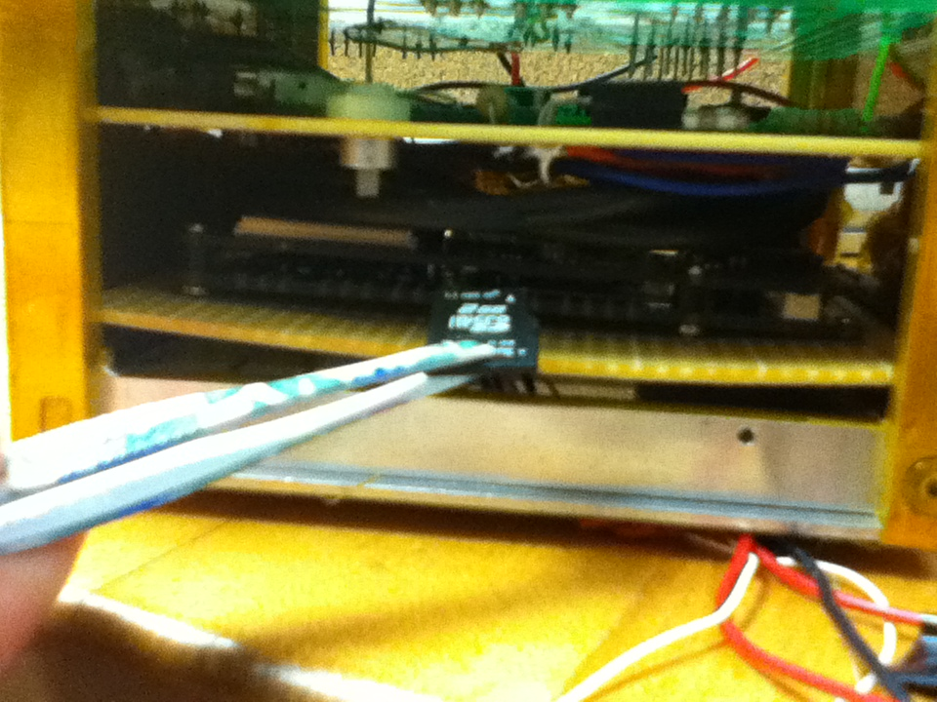
Clamp
SD Card

- To format the payload remove the Micro SD card from the board and place it in a SD card adapter so that it can be formatted using a computer.

- Verify that data is received from the payload to the communication station and also be saved in the micro SD card, by removing the SD card after following step d.

- List all checks that will determine a successful integration:

STEPS | Checks
- Place mounting plate with payload on the HASP platform with 4 nuts and bolts on the comers.

- Connect the HASP power cable to the EDAC power connector to the payload platform.

- Connect the telemetry cable (DB9) to the to the payload platform.

- Verify that the LED on the board is ON by following steps in section V

- Verify that data is received from the payload to the communication station.

Table 3: Checks that will determine a successful integration

- List any additional LSU personnel support needed for a successful integration other than directly related to the HASP integration (i.e. lifting, moving equipment, hotel information/arrangements, any special delivery needs):
None
- List any LSU supplied equipment that may be needed for a successful integration:
- 30V @ 1Amp power supply

