Payload Flight Number:  20016-09 | Institution:  University of Central Florida
Payload Title:
Hazardous Gases for Harsh Environments LED Sensor
Student Leader:  Michael Villar (Graduate Student)  Mechanical and Aerospace Engineering  4000 Central Florida Blvd  Orlando, Florida, 32816  mvillar@knights.ucf.edu  Cell: (561) 512-3953 | Faculty Advisor:  Dr. Subith Vasu  Mechanical and Aerospace Engineering  4000 Central Florida Blvd  Orlando, Florida, 32816  subith@ucf.edu  Office: (407) 823-3468
Current Team Members:
Justin Urso (Graduate Student)  Mechanical and Aerospace Engineering  4000 Central Florida Blvd  Orlando, Florida, 32816  Justin.urso13@knights.ucf.edu  Cell: (352) 817-9212 | Akshita Parupalli (Undergraduate Student)  Mechanical and Aerospace Engineering  4000 Central Florida Blvd  Orlando, Florida, 32816  Akshita.parupalli@knights.ucf.edu  Cell: (321) 696-9969
Past Team Members:
Kyle Thurmond (Graduate Student)
Mechanical and Aerospace Engineering
4000 Central Florida Blvd
Orlando, Florida, 32816
kthurmond@knights.ucf.edu
Cell: (407) 617-0475

Report Month:  July | Report Date:  7/27/2016
Gantt Chart:

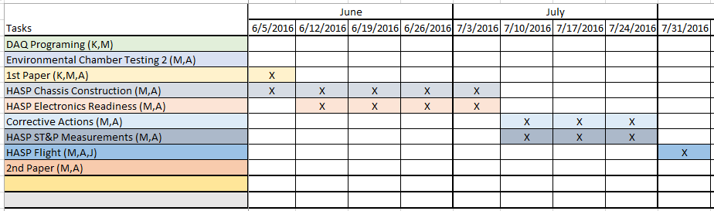
Team Member Activities:

Michael Villar worked on finalizing the transition to the new design by migrating electronics, optical components, and the DAQ. Once the payload chassis was built and all components were securely fastened, the system was tested under standard laboratory settings. The tests were satisfactory and indicated that the system is performing as anticipated.

Justin Urso mainly assisted with design and construction of the new setup. He was also available during testing and troubleshooting in the laboratory setting.

Akshita Parupalli focused on designing and creating the improved gas cell. The cell is airtight, so no significant amount of gas will escape. Sapphire windows were more securely attached, and the entire system was sealed and joined together with the use of a strong epoxy.

System Updates:
- Update: Built the Payload chassis and secured the necessary components inside
  - The chassis was built with aluminum rods and aluminum plates. Once these were drilled and screwed together, the important electronics were all attached via screws to the walls and to the bottom of the chassis.
- Update: Completed gas cell and attached it to the chassis
  - After the cell components were attached via epoxy, the entire optical rail was attached to the chassis via screws. An aluminum box was attached to the payload base in order to serve as a limiting container for the diaphragm. The diaphragm is made of latex and should not expand to its full size in any case.

