|  |  |
| --- | --- |
| [penn state](http://www.psu.edu/) | 0000-00-0000  Rev. 001 |

**Final Program Report**

*OSIRIS Lite (2010) and OSIRIS Lite 2 (2011)*

**Student Space Programs Laboratory**

332 Electrical Engineering East, University Park, PA 16802

Phone: 814-867-2256

16 December 2011

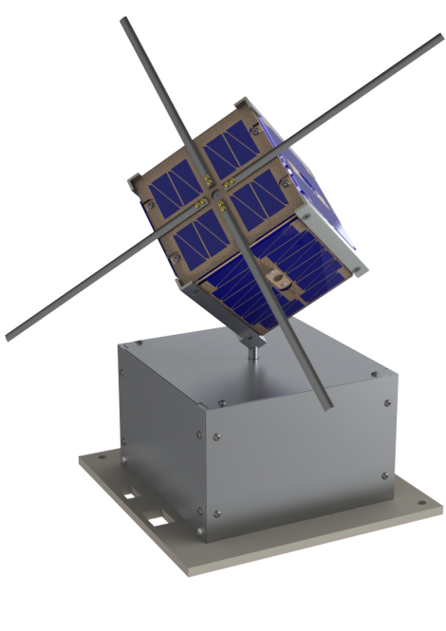This document does not contain proprietary information related to The Pennsylvania State University’s Student Space Programs Laboratory (SSPL). This document is not intended for public release.

SIGNATURES

_________________________________________ __________________

Allen Kummer Date

OSIRIS Lite 2 Project Manager

The Student Space Programs Laboratory

_________________________________________ __________________

Sven Bilén Date

Director

The Student Space Programs Laboratory

*(All Signatures on File with the SSPL)*

REVISION HISTORY

|  |  |  |  |
| --- | --- | --- | --- |
| **Version** | **Date** | **Author** | **Description** |
| 001 | 12/16/2011 | Allen Kummer | HASP Version |
|  |  |  |  |

RELEVANT DOCUMENTS

|  |  |  |
| --- | --- | --- |
| **Doc. Number** | **Title** | **Rev** |
|  |  |  |
|  |  |  |

*Relevant documents are available on the SSPL web server when available

ACRONYMS

|  |  |
| --- | --- |
| CAD | Computer Aided Design |
| CDH | Command and Data Handling |
| CSS | CubeSat Simulator |
| HASP | High Altitude Student Platform |
| OLite 2 | OSIRIS Lite 2 |
| OSIRIS | Orbital System to Investigate the Response of the Ionosphere to Stimulus and Space Weather |
| SB | Support Box |
| SSPL | Student Space Programs Laboratory |
| TRL | Technology Readiness Level |

Final Report

TABLE OF CONTENTS

SIGNATURES i

REVISION HISTORY ii

RELEVANT DOCUMENTS ii

ACRONYMS 2

TABLE OF CONTENTS 3

LIST OF FIGURES 4

LIST OF TABLES 4

1.0 Overview 1

1.1 Introduction 1

1.2 Mission Objectives 1

1.3 OLite 2 Mission Composition 2

2.0 Mission Results 3

2.1 Summary Flight Line Problems 3

2.2 Failure Analysis 3

3.0 Project Summary 6

3.1 Conclusions 6

3.2 Future Work 6

Appendix A Lessons Learned 7

Appendix B List of Participants 9

LIST OF FIGURES

Figure 1 OLite 2 CAD model 2

Figure 2 Support Box power system diagram 4

Figure 3 Offending SB internal connection 5

# Overview

## Introduction

The OSIRIS Lite (OLite) and OSIRIS Lite 2 (OLite 2) missions are technology demonstration missions utilizing NASA’s High Altitude Student Platform (HASP) to demonstrate key CubeSat technologies. Students at the Student Space Programs Laboratory (SSPL) are developing a common spacecraft bus that can be used on a number of proposed missions. OLite and OLite 2 are two development missions with the goal of initially developing the technologies (OLite) and miniaturizing them to the CubeSat form factor (OLite 2). OLite was originally slated to fly as part of HASP 2010 and OLite 2 as part of HASP 2011.

While OLite was developed for the HASP 2010 flight, when the flight was delayed by a year due to the balloon accident in Australia, SSPL chose to take the lessons learned from designing, building, and testing the OLite system and move forward with developing the CubeSat form factor for OLite 2. Architecture changes between OLite 1 and OLite 2 made it more practical to move forward with OLite 2 and abandon the OLite 1 payload for flight in 2011. Focus was thus put on developing the OLite 2 mission rather than maintaining legacy hardware and interfaces in OLite 1.

## Mission Objectives

The OLite 2 mission objectives are listed below.

1. Educate the student team developing the spacecraft bus in mission development, design, build, and verification to prepare for a CubeSat flight mission.
2. The communications subsystem shall data downlink over the main radio, beacon downlink, and data uplink in near satellite flight like conditions.
3. The guidance and navigation subsystem shall demonstrate the OSIRIS satellite GPS operation, attitude sensors, and attitude determination algorithm in a relevant near-space environment.
4. The power subsystem shall demonstrate power generation, storage, and supply for the satellite in near-space like conditions.
5. The mechanical subsystem shall demonstrate antenna deployment in flight configuration in a laboratory environment.
6. The thermal subsystem shall demonstrate modeling and operation of both passive and active heater control algorithms by maintaining temperature in the rarified gas high altitude balloon environment.
7. The command and data handling subsystem shall demonstrate command handling through flight software and control of each subsystem throughout the flight.

## OLite 2 Mission Composition

While HASP provides a good analog for satellite flight for such things as demonstrating operational control, attitude determination, and solar power generation, the thermal environment and system ConOps are vastly different. Two of the most noticeable differences are the necessity to include convection in thermal design for the balloon and the differences in sun/eclipse profiles since the balloon does not experience the same 90-minute cycles the satellite will experience. To be able to keep the CubeSat design from being impacted by these differences and the differences in power and communications provided by HASP, the system was broken into two components, the CubeSat Simulator and the Support Box.

The support box (SB) is the bottom portion of the system and is composed of power control and data interface handling. The CubeSat Simulator (CSS) is the top portion of the payload and is designed to meet the size constraints of a CubeSat. The CSS includes a power generation system, attitude determination capabilities, thermal control circuitry, a flight computer, and 430-MHz radio which make up the CubeSat spacecraft bus.

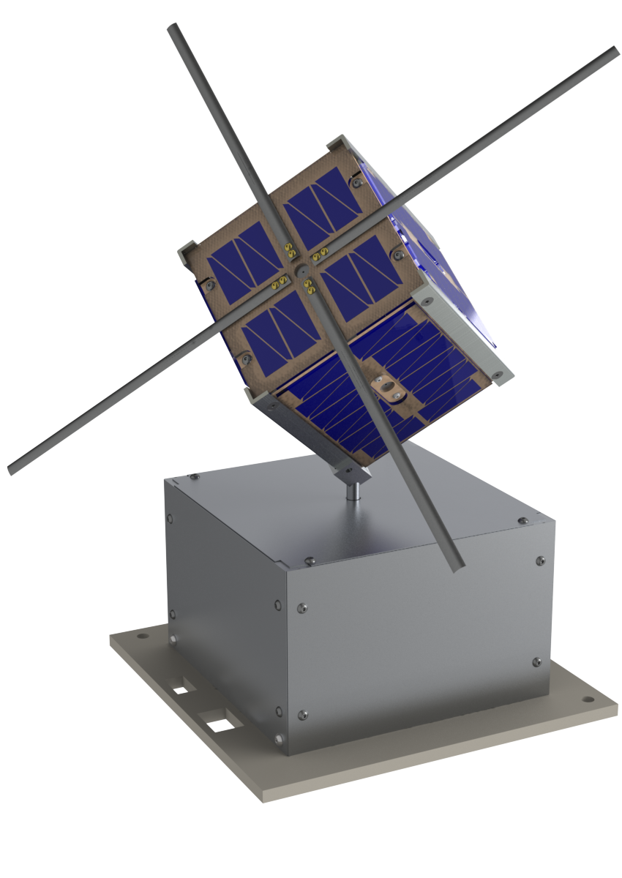

Figure OLite 2 CAD model

# Mission Results

## Summary Flight Line Problems

OLite 2 was brought back to Penn State after integration testing in Texas to continue some work on the system. OLite 2 was shipped to the HASP 2011 flight without any Penn State personnel accompanying the payload or planning on attending the launch. Prior to shipment, functionality tests were performed to verify that the system was operating properly. These included repeating thermal environmental testing that was performed at the original integration in Texas.

The payload was reintegrated to the HASP flight system by HASP personnel with initial turn-on initiated after a conversation with the OLite 2 project manager. The expected outcome from this turn-on test was to see a current around 350 mA and data over the HASP RS-232 downlink connection. After 5 minutes of on time an average current of 5 mA and no data was recorded. Further symptoms of the flight line problems are:

* No data from CSS
* Steady state current draw reported by HASP around 5 mA
* No lights on power regulation board are visible
* SB connector to CSS not supplying power

From the symptoms presented, it appears that the SB was not supplying supplemental power to the CubeSat. To accommodate the variation in thermal environment on the balloon flight, more heaters were added to the CubeSat in an always on state. This means that supplemental power off of HASP through the SB was required on a regular basis to charge the flight batteries. Since Penn State students were not on site to debug the problem, and the proposed solutions could not be implemented by HASP personnel due to time constraints, the payload was not able to be included for flight when the balloon launched since power was not being provided by the SB to the CubeSat to turn it on and charge the system batteries.

## Failure Analysis

The Support Box regulates the 30-V HASP power line to provide a 4.2-V power bus for charging the CSS batteries. Figure 2 shows the SB internal connections. There were a pair of DC–DC regulators within the SB connecting directly to the 30-V line. These provided 3.3 V and 5 V for the CDH board and CSS Charger respectively. To achieve some ConOps testing, the 5-V regulator powering the CSS Charger utilized a shutdown pin controlled by the CDH board. This turns off the CSS Charger and allows the CubeSat to operate completely under its own power for a period of time during the flight. The CSS Charger then connects directly to the CSS through a wiring harness external to the SB.

The flight line symptoms showed that no power was coming out of the connector on the SB; therefore, no power was provided by the CSS Charger itself. This condition can be caused by

* CDH stuck pulling the shutdown pin low (Shutting down the charger)
* The 5-V charger board itself being broken
* A disconnected wire along the path from HASP power to the 5-V regulator to the CSS Charger and finally out to the CSS

Figure Support Box power connections

|  |
| --- |
|  |

* The CSS Charger itself being broken

Since the SB itself was drawing very little current it appeared that the CDH board itself was not turning on. Thus, when the CDH board is off, the regulation board shutdown pin is pulled low by (by default) and the CSS power is shutoff at the 5-V regulator. The CDH board could not be turning on because

* The 3.3-V regulator powering it is broken
* A wire is broken between the HASP power and the 3.3-V regulator
* A wire is broken between the 3.3-V regulator and the CDH board
* The CDH board itself is broken

No further debugging could be done from outside the SB so the next step was to open up the support box. With the SB open, by inspection it was easy to see that the power line was disconnected from the terminal block on the top regulator. This regulator supplies the power for the CDH system and the RS-232 level converter used to communicate between the SB and the HASP flight system. The data out of the CSS is directly connected to the HASP RS-232 receive pin through this device also preventing data from being directly downlinked from the CSS to the balloon system in the event that there had been some power left in the CSS batteries after shipping, potentially having allowed the CSS to communicate before debugging began.

|  |
| --- |
| Figure Offending Support Box connections |

Once the connection was made between the 30-V line and the 3.3-V regulator, the system once again began functioning properly. Thus, problems on the flight line came down to a connection that slipped out during transit between Penn State and the flight line in New Mexico. This may have been eliminated by assuring that the screw was properly tightened down before shipping or by using a better mechanical connection that is physically locked in place, e.g., soldering the wires directly to the board.

# Project Summary

## Conclusions

From both an educational standpoint and technology development standpoint, the OLite 2 mission was a success even without the flight. Going through the stages of the mission, from conception through design, building, and testing, presented students with an excellent introduction to mechanical, electrical, computer, and systems engineering.

Many of the mission objectives were met through ground-based environmental testing in the SSPL thermal and thermal–vacuum chambers. All the systems were demonstrated to be operational in a vacuum environment (~5×10−4 Torr) where the integrated CubeSat was tested cycling between the system states as would be done on orbit. Further, attitude determination and power generation systems were shown to function in an outdoor test with the system mounted on a tripod.

Had a student traveled with the payload to flight (not possible due to timing of launch at the beginning of the semester and cost) or the availability of some limited time from support staff, the problems found during integration on the flight line could have been overcome quickly. As it was, once the payload was back at Penn State, the system was completely operational again within an hour. There would have been more than enough time down at the launch site to overcome the disconnected problem and this would have allowed the payload to fly.

Appendix A Lessons Learned

* Create Altium board outlines from the STEP files produced by the mechanical team
* Import circuit boards with major parts on them from Altium to SolidWorks at PDR for fit checks
* Standardize board orientation early on in the design process
  + In SolidWorks, clearly mark the tops and bottoms of the boards
  + Standardize on Pin 1 location
* Review all footprints for proper pinouts during subsystem critical design review (prior to purchasing boards)
* Only modify commercially bought flight hardware if the cost of redesigning your board is significantly greater than the cost of replacing the commercial hardware
* Rated regulator efficiencies can be very wrong (expected >90%, got <82%)
* Record all channel data from the CubeSat as it is received so tests do not have to be repeated
* Manpower is everything; keep team members engaged so that when you do need them they are still around.
* When running an automatic test, make sure it logs the data as it takes it, instead of at the very end. Sometimes the program gets quit accidentally, power goes out, etc., and data would otherwise be lost if the test was not finished.
* Double check which side (top or bottom) of the solar cell is power and ground
* Make sure that all devices on a communications bus operate at a common voltage level
* Masking tape may have conductive adhesive?
* For small pads (i.e., connector pads), put a via through them to help them stay on the board
* Have capability of completely isolating batteries from ALL other circuitry.
  + Allows safer spot welding of the battery before any circuitry is populated
  + Allows for full system shutoff during testing and/or not using battery constantly
* **ALWAYS purchase wide temperature range components!**
* Environmental testing is done with dry nitrogen in the chamber at atmospheric pressure at CSBF, do likewise testing (this is not stated in the HASP users guide)
* NEVER neglect your thermal team, heaters and potting are necessary when recommended
* Provide adequate power margin for heaters
* Research and understand the environment and testing conditions prior to integration testing
* Have a tested method of flashing the CDH board when you travel
* Make sure the master schematic book includes ALL circuits
* Spend more time on packing list and verifying packing of those items
* Consider signal integrity early on. Include flexibility to put in current limiting resisters in series and a matching network on the communications lines
* Consider connector location with respect to other components in the system, recognizing where connectors will need to be accessed in relation to other boards (import connectors into SW)
* Use components with easily verifiable connections, i.e., different distro switches
* **Keep in mind the mission objectives, post those somewhere within the lab**
* Do not rely on NAND memory to be persistent over a wide range of temperature
* Terminate all inputs (particularly UART pins, we saw the programming pins hold the μC in reset)
* Assure adequate gain for the GPS system ground testing
* Put LEDs someplace visible from outside and make sure current flow through each is equal (CDH board LEDs inside and not visible)
* Record ALL information when placing an order including whom you talked to, PO #, full part number, quantity, etc.
* Confirm indices (ji vs ij) because they are not consistent across all references
* Place power and ground connections sufficiently far apart to assure that things can't get shorted (battery terminal to ground)
* Do proper systems engineering on all portions of the mission (not just the ones you like to play with)
* Wiring should be mechanically connected (screw terminal blocks aren't permanently connected)
* Paint faces of SolidWorks circuit board models to define orientation
* Model signal integrity of communications buses before manufacturing
* Properly terminate high speed communications buses
* Hold software design reviews
* Avoid compound angles in mechanical designs (or have HUGE tolerances)
* Prototype ALL circuits before designing the final board
* Have a systems engineer
* Consider battery mounting in design of the battery board (have something mechanically rigid)
* Include a battery-remove-before-flight pin in the design to inertly connect the battery
* Make sure there is sufficient spacing for test points, be careful about tearing pads off
* Include all relevant part information in the part library

Appendix B List of Participants

|  |  |  |  |  |
| --- | --- | --- | --- | --- |
| 1 | Aaron | Horn | Junior | Computer Science/Engineering |
| 2 | Adam | Covino | Junior | ; Aerospace Engineering; |
| 3 | Ajeeth | Ibrahim | Sophomore |  |
| 4 | Akul | Girish | Freshman | ; Computer Science/Engineering; |
| 5 | Alex | Hackett | Masters | ; Electrical Engineering; |
| 6 | Alex | Bersani | Junior | Electrical Engineering |
| 7 | Alex | Rejmaniak | Sophomore |  |
| 8 | Allen | Kummer | Masters | ; Electrical Engineering; |
| 9 | Amanda | Schweitzer | Sophomore | ; Mechanical Engineering; Nuclear Engineering; |
| 10 | Anant | Mathur | Junior | ; Computer Science/Engineering; |
| 11 | Andre | Coleman | Sophomore | ; Aerospace Engineering; |
| 12 | Andrew | Palski | Senior | ; Aerospace Engineering; |
| 13 | Artem | Busorgin | Junior | ; Aerospace Engineering; Math; |
| 14 | Chris | Shotter | Junior | Electrical Engineering |
| 15 | Connie | Ruiz | Junior | ; Aerospace Engineering; |
| 16 | Corey | Friedenberger | Senior | ; Aerospace Engineering; |
| 17 | Corey | Stubbs | Senior | ; Computer Science/Engineering; |
| 18 | Courtney | Boehmer | Freshman | Electrical Engineering |
| 19 | Craig | Hammond | Freshman | ; Computer Science/Engineering; Nuclear Engineering; |
| 20 | Dan | Aglione | Junior | ; Mechanical Engineering; |
| 21 | Daniel | Gilbert | Sophomore | ; Computer Science/Engineering; |
| 22 | David | Zhang | Senior | ; Computer Science/Engineering; |
| 23 | Devin | Simpson | Junior | Computer Science/Engineering |
| 24 | Eric | Gilligan | Junior | ; Aerospace Engineering; |
| 25 | Eric | Root | Senior | ; Electrical Engineering; |
| 26 | Ersin | Selvi | Sophomore | ; Electrical Engineering; |
| 27 | Fan | Zhang | Junior | ; Computer Science/Engineering; |
| 28 | Francisco | Matias | Senior | ; Electrical Engineering; |
| 29 | Jacob | Kurien | Masters | ; Electrical Engineering; |
| 30 | Jake | Ndjali | Junior | ; Aerospace Engineering; |
| 31 | James | Crowley | Freshman | ; Undecided; |
| 32 | James | Meyer | Senior | ; Computer Science/Engineering; |
| 33 | Jeff | Jesiolowski | Junior | ; Aerospace Engineering; |
| 34 | Jesse | McTernan | Masters | ; Aerospace Engineering; |
| 35 | Josh | Panning | Junior | ; Aerospace Engineering; |
| 36 | Josh | Miller | Senior | ; Electrical Engineering; |
| 37 | Kenrick | Dacumos | Sophomore | ; Electrical Engineering; |
| 38 | Kwok | Cheng | Senior | ; Aerospace Engineering; |
| 39 | Lawrence | DiGirolamo | Junior | ; Aerospace Engineering; |
| 40 | Mark | Bartels | Junior | ; Electrical Engineering; |
| 41 | Matthew | Becker | Junior | ; Aerospace Engineering; |
| 42 | Michael | Boeckel | Junior | ; Aerospace Engineering; |
| 43 | Michael | Morden | Masters | ; Electrical Engineering; |
| 44 | Michael | Whitfield | Junior | ; Electrical Engineering; |
| 45 | Michael | Matas | Sophomore | ; Aerospace Engineering; |
| 46 | Mike | Moser | Sophomore |  |
| 47 | Miles | Frain | Sophomore | ; Electrical Engineering; |
| 48 | Miles | Wright | Sophomore | ; Electrical Engineering; |
| 49 | Nandish | Pathak | Sophomore | ; Mechanical Engineering; |
| 50 | Nate | Butler | Sophomore | ; Electrical Engineering; |
| 51 | Nathan | Blinn | Sophomore | ; Electrical Engineering; |
| 52 | Philip | Gorman | Masters | ; Electrical Engineering; |
| 53 | Ravender | Virk | Sophomore | ; Electrical Engineering; |
| 54 | Robert | D'Alonzo | Junior | ; Aerospace Engineering; |
| 55 | Robert | Soldner | Junior | ; Computer Science/Engineering; |
| 56 | Ryan | Baer | Junior | ; Computer Science/Engineering; |
| 57 | Ryan | Brady | Junior | ; Computer Science/Engineering; |
| 58 | Scott | Teal | Senior | ; Electrical Engineering; |
| 59 | Scott | Pfeiffer | Senior | ; Electrical Engineering; |
| 60 | Sean | McFarlane | Sophomore | ; Electrical Engineering; |
| 61 | Steve | Zesch | Senior | ; Computer Science/Engineering; |
| 62 | Steve | Devore | Junior | ; Electrical Engineering; |
| 63 | Swarna | Sinha | Junior | ; Aerospace Engineering; Math; |
| 64 | Timothy | Brubaker | Sophomore | ; Electrical Engineering; |
| 65 | Tom | Roher | Junior | ; Engineering Science; |
| 66 | Tsungshun | Tu | Junior | ; Mechanical Engineering; |
| 67 | Tucker | Connors | Junior | ; Electrical Engineering; |
| 68 | Ty | Druce | Freshman | ; Aerospace Engineering; |
| 69 | Tyler | Boehmer | Masters | ; Electrical Engineering; |
| 70 | Vincent | San Miguel | Sophomore | ; Aerospace Engineering; |
| 71 | Yiqing | He | Sophomore | Electrical Engineering |
| 72 | Zach | Leuschner | Junior | Electrical Engineering |