**HASP 2010**

**Science Report on Payload # 7 of**

**University of North Dakota and University of North Florida**

**“Detection of ozone profile in stratosphere using nanocrystalline and nanocomposite sensors arrays and high altitude balloon flight”**

**Students Team Leader: Jonathan Wade Snarr**

**Students Team: Nathan Walker, Jason Saredy and Bernadette Quijano (UNF)**

**Faculty Advisors:**

**Dr. Ron Fevig**

Department of Space Studies, University of North Dakota (UND), Grand Forks, ND 58202

**and**

**Dr. Nirmalkumar G. Patel**

Department of Physics, University of North Florida (UNF), Jacksonville, FL 32224



**Introduction and Aim**

**Ozone in the Stratosphere:** Oxygen gas (O2) is present in the atmosphere. High energy or shorter wavelength UV light collides with the oxygen molecule (O2), causing it to split into two oxygen atoms. These atoms are unstable, and they prefer being "bound" to something else. The free oxygen atoms then smash into other molecules of oxygen, forming ozone (O3).

O1 (atom) + O2 (Oxygen gas) → O3 (Ozone)

The ozone is destroyed in the very process that protects us from UV rays emitted by the Sun. When ozone (O3) absorbs UV light, it will split the molecule into one free oxygen atom (O1) and one molecule of oxygen gas (O2).

O3 (Ozone) → O1 (atom) + O2 (Oxygen gas)

Ozone is valuable to us because it absorbs harmful UV radiation during its distortion process.

**Ozone in the Troposphere:** Ozone in the troposphere is not good for breathing. This ozone is contributing to the smog and greenhouse gases created by human activities. Ozone close to the ground surface does not exist in high enough concentrations to shield us from UV light.

Looking into the importance of ozone in the stratosphere, University of North Dakota (UND) and the University of North Florida (UNF) jointly collaborated on a scientific project to measure the ozone profile in the stratosphere. High Altitude Student Platform (HASP)-NASA provided a platform for 12 small payloads and 4 large payloads. The maximum mass limit was 20 kg for a large payload, and 3 kg for a small payload. UND and UNF jointly had one small payload. UNF’s responsibility was to provide the gas sensors system, payload body and data analysis, while UND’s responsibility was to provide the microcontroller circuit, software, and electronic communication circuits. The Florida Space Grant Consortium provided financial support to the UNF team. The HASP had an onboard computer, power supply batteries, GPS, video camera, and communication link for all payloads. During the first week of August 2010, the UND and UNF team met at the NASA-Columbia Scientific Balloon Facility (CSBF) in Palestine, Texas for the integration of the sensors and electronic circuits that made a complete UND-UNF payload. The payload was then fixed on to the HASP platform. The UND-UNF payload successfully passed all required thermal vacuum tests and certified for the flight. The 2010 flight was cancelled during 2010 and was rescheduled to launch in 2011. The payload was again tested and recalibrated at the UNF during last week of July 2011. Then, the payload was again tested at CSBF, Palestine during the first week of August 2011 and cleared all thermal vacuum tests. The HASP2010 flight was launched successfully by NASA-CSBF on August 31, 2011 from Fort Sumner, New Mexico. The flight duration was about 12 hours. During the flight, the UNF ozone sensors array worked and detected ozone in the stratosphere. The payload sent out a data files during the flight without any problem. After the termination of the balloon flight, the payload landed safely on the ground using a parachute. Then, the payload was recovered. The technical details, pictures and science results of this flight are highlighted in this report.

**Fabrication of Sensors**

Fig. 1 shows the top view of one typical low magnification scanning electron microscope image of the Indium Tin Oxide (ITO) thin film gas sensor having two gold electrodes for external electrical contacts.

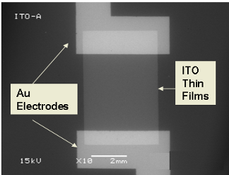

Fig.1 Scanning electron microscope image of top view of one ITO gas sensor

Fig. 2a shows a typical array of 24 ITO gas sensors fabricated on an approximately 7.5cm x 2.5cm glass slide by the vacuum deposition method at UNF. The interface of the cicuit board to the array is also shown in Fig.2a. Fig. 2b shows the three groups of sensors used.

**Group #1** sensors are nanocrystalline ITO thin film deposited on glass.

**Group #1** has sensors #S1,S2,S3,S4,S13,S14,S15, and S16.

**Group #2** sensors are nanocomposite of ZnO and ITO thin film deposited on glass.

**Group #2** has sensors #S5,S6,S7,S8, S17, S18, S19, and S20.

**Group #3** sensors are nanocomposite of WO3 and ITO thin film deposited on glass.

**Group #3** has sensors #S9,S10, S11, S12,S21,S22,S23 and S24.

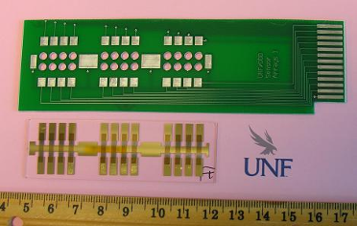

Fig. 2a Array of 24 ITO gas sensors with interface circuit board (PCB) (UNF Patent pending)

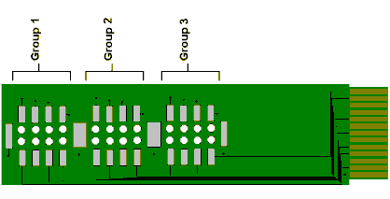

Fig. 2b Schematic diagram of three groups of sensors array with interface circuit board (PCB)

Fig. 3 (a) shows the schematic diagram of housing for the UNF sensors, consisting of an array of 24 ITO gas sensors interfaced with a printed circuit board (PCB), flexible Kapton heater (Omega make KHLV-0502/10-P), temperature sensor, electrical fan and a 26 pin flat cable, while fig.3(b) shows inner and outer views of the sensors box. In addition to the sensors box for the payload, one backup sensors box and two additional sensor arrays were fabricated. All were tested in the thermal vacuum test chamber.

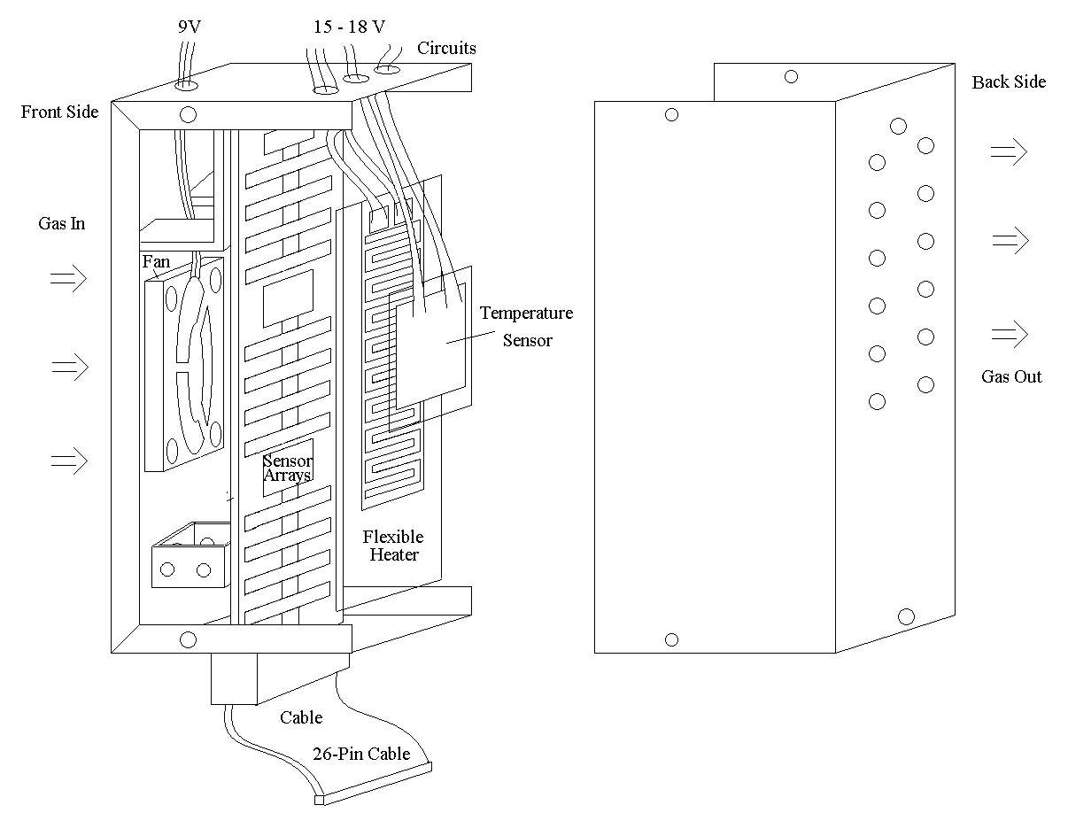

Fig.3 (a) Schematic diagram of sensor box

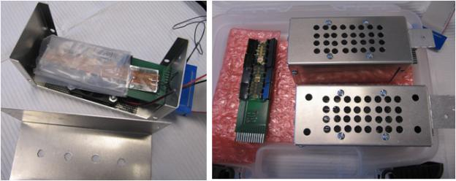

Fig.3 (b) Inner and outer view of UNF Ozone sensors box

**Working Principle of Sensors**

**Interaction of oxidizing gas on surface of n-type ITO thin film sensor**

Upon adsorption of charge accepting molecules at the vacancy sites, namely from oxidizing gases such as ozone (O3), these electrons are effectively depleted from the conduction band of ITO. This leads to an increase in the electrical resistance of n-type ITO.

***For ozone gas***:

**Oxygen vacancy (V) + Ozone (O3) →Lattice Oxygen site (Oo) + O2**

Vacancies can be filled by the reaction with ozone. Filled vacancies are effectively electron traps and as a consequence the resistance of the sensor increases upon reaction with ozone.

**Interaction of reducing gas on surface of n-type ITO thin film sensor**

Oxygen vacancies on ITO surfaces are electrically and chemically active. These vacancies function as n-type donors decreasing the electrical resistivity of ITO. Reducing gases such as CO, H2 and alcohol vapors result in detectable decreases in the electrical resistance of n-type ITO.

***For methanol:***

**CH3OH (methanol) + O− (chemisorbed ion on surface of ITO)**

**→ HCOH (Formaldehyde) + H2O (water) + e− (electron)**

Vapors come in contact with the surface and react with chemisorbed oxygen ions O- or O2- and re-inject electrons into the conduction band.

In summary, the electrical resistance of ITO increases in the presence of oxidizing gases such as ozone. Upon adsorption of the charge accepting molecules at the vacancy sites, namely oxidizing gases such as ozone, electrons are effectively depleted from the conduction band, leading to an increase in the electrical resistance of n-type ITO.

**Calibration of ITO Sensors**

The ITO sensors array was first tested and calibrated in the test chamber at UNF. The test chamber was adjusted to nearly identical coonditions of temperature and pressure in the startosphere. Fig. 4(a) shows the pictures of ozone generator and detector used for the calibration of sensors. An ozone gnerator (Ozone Solutions, Model# OMZ-3400) was used as the source of ozone, which generated 0 to 12 ppm ozone gas. A digital ozone detector(Eco Sensors, Inc., Model:A-21ZX) was used to measure the concentration of ozone in part per million (ppm). Fig. 4b shows the Keithley digital multimeters / electrometers used for the measurements of the ITO sensor’s resistance.

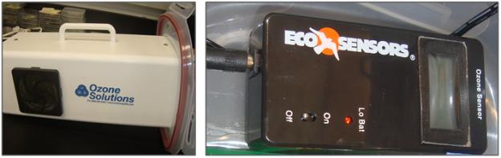

Fig.4a Ozone generator and digital ozone detector

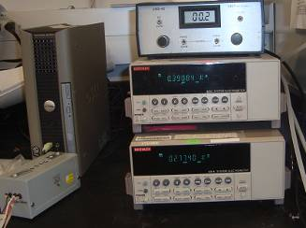

Fig. 4b Keithley multimeter/ electrometers used for the calibration of snesors

Sensors were calibrated during July 2010. All the 24 sensors of sensors box was again calibrated simulataneously under indetical conditions of pressure, temepratue and concnetration of ozone in the test chamber during July 2011. It was observed that sensors performance was improved after one year. Sensors shown only two linear ranges in 2010, while it was imporved to one linear range in 2011. This improvement may be due to the saturation and stabilization of self oxiding of surface of sensors with time.

Figs. 5(a) to (r) show the calibration plots ozone sensors of Group#1, 2 and 3 of sensors box. The calibrations were made in July 2011. The sensors were calibrated with ozone gas in the range of 0.02 to about 11.0 ppm under low pressure in the test chamber. The usual variation of ozone in the stratosphere is about 4.5 to 8.5ppm. The measured data fit linearly and trendline equations for each plot were determined.

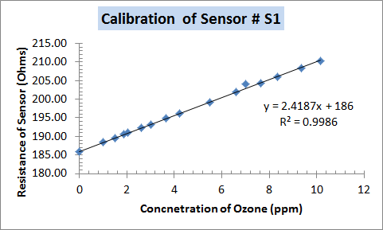 Fig 5 (a) 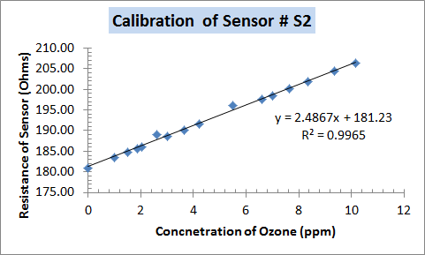 Fig 5 (b) 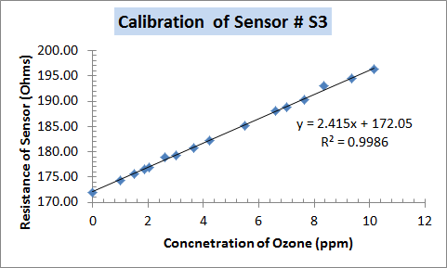 Fig 5 (c) 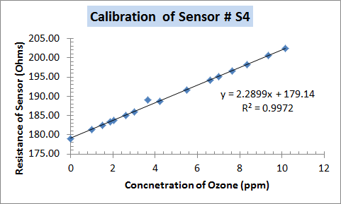 Fig 5 (d) 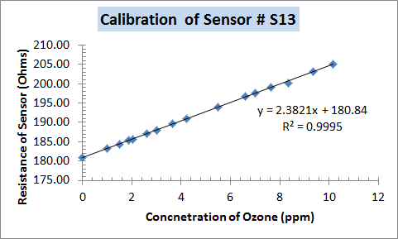 Fig 5 (e) 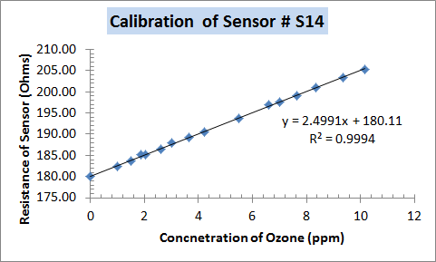 Fig 5 (f) 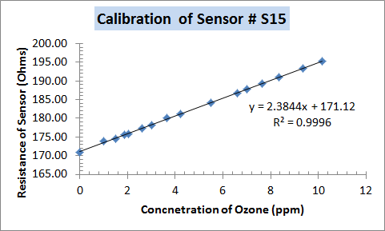 Fig 5 (g) 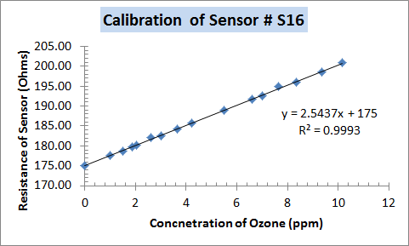 Fig 5 (h) 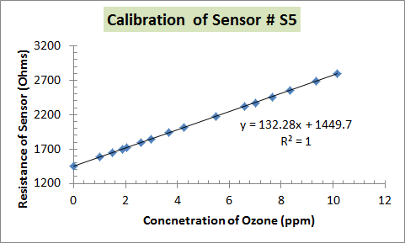 Fig 5 (i) 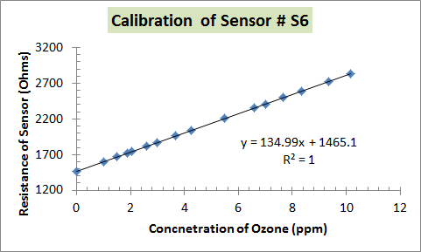 Fig 5 (j) 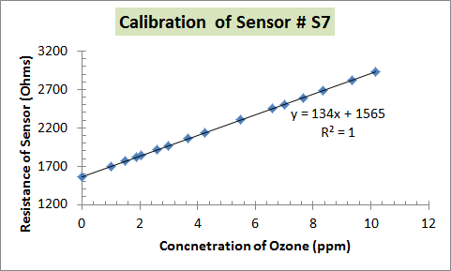 Fig 5 (k) 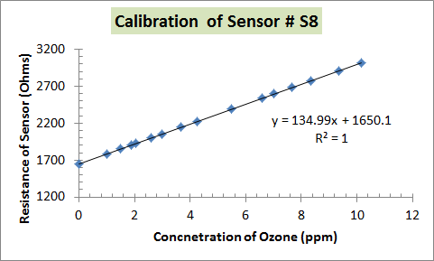 Fig 5 (l) 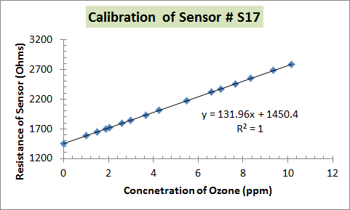 Fig 5 (m) 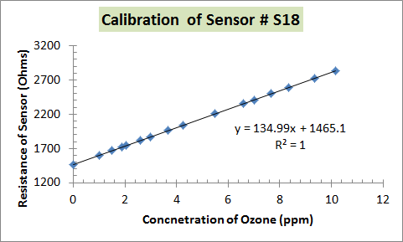 Fig 5 (n) 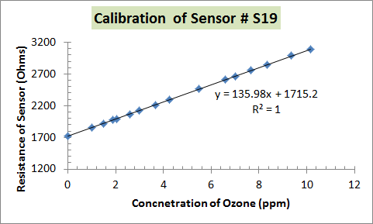 Fig 5 (o) 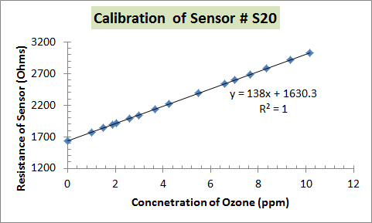 Fig 5 (p) 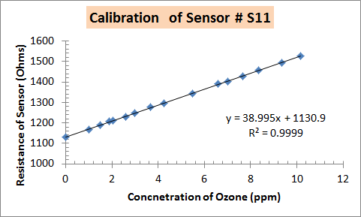 Fig 5 (q) 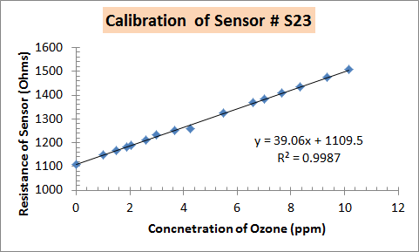 Fig 5 (r)

Fig.5 (a) to (r) Calibration plots of sensors

All sensors were calibrated three times and showed nearly the same nature of response each time. The trend line equation for each sensor was determined. Some small variations in the slope and y-intercept values were observed due to experimental error.

**Payload Structure**

The payload frame structure was made of aluminum (Al 6061), and the walls of the payload were made with PVC sheets. Fig.6 shows a schematic of the payload structure. The dimensions of payload were 296mm x 141mm x 141mm, which were within the requirement of being less than 300mm x 150mm x 150mm.

.

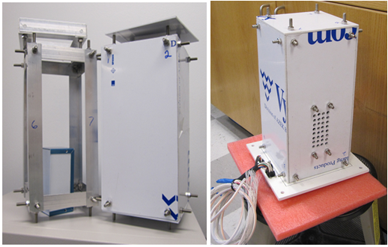

Fig.6 Payload body structure

Fig.7 shows mass of various parts of the payload.

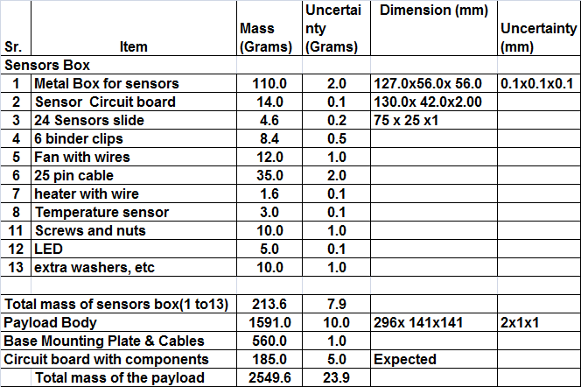

Fig.7 mass of various parts of the payload

The total mass of payload excluding its base plate was about 2.0 kg, which was less than the limit of 3.0 kg.

**Cirucit diagrams**

Jonathan Snarr (UND) developed the micorcontroller circuits, which is shown in fig. 8 (a) and (b)..



**Fig. 8(a) Microcontroller circuit for payload**



**Fig.8 (b) Outer dimnesionof PCB.**

The payload body, sensors box and circuit board were interegrated at the the CSBF, Palestine during the first week of August 2010.

**Thermal Vacuum Test**

The UND-UNF payload was tested in the BEMCO chamber, which is shown in Fig. 9(a) and (b) for high temperature (56oC), low temperature (-60 oC), high pressure (1.5 atm), and low pressure (down to 1mbar). The payload sucessfuly cleared the thermal vacum test at the CSBF, Palestine, TX in the first week of August 2010 and again in the first week of August 2011.

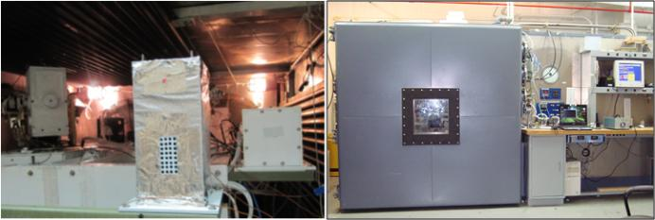

Fig.9 Testing of payload in the thermal vacuum test chamber at the CSBF, Palestine, TX during August 2010.

Fig.10 shows the picture of Jonathan(UND) with the UND-UNF payload at the CSBF, Palestine in August 2011.

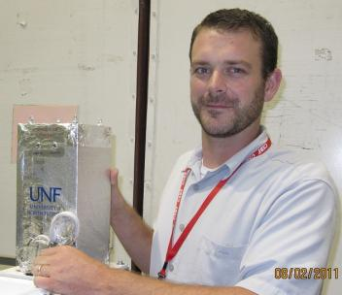

Fig.10 Jonathan Wade Snarr (UND) with the UND-UNF payload.

**Launching of Payload**

Fig. 11 shows the preparation of flight launach at the CSBF, Fort Sumner, NM on August 31, 2011. The UND-UNF payload is shown in the same picture. Fig. 12 shows the picture of high altitude balloon with the HASP.

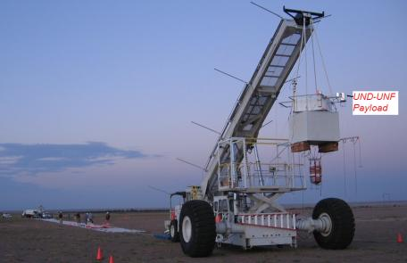

Fig.11 Preparation of launch

(Courtesy: http://laspace.lsu.edu/hasp/images/2010/launch/imagepages/image32.php)

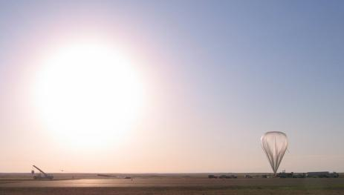

Fig.12 HASP2010 Balloon ready for launch

(Courtesy: <http://laspace.lsu.edu/hasp/images/2010/launch/imagepages/image46.php>)

The onboard “Cosmo Cam” video camera with GPS System provided real time video, as well as data for altitude, latitude, longitude, pressure and temperature during the flight. Fig. 13 shows one of the pictures taken by the “Cosmo Cam” camera, which shows the UND-UNF payload.

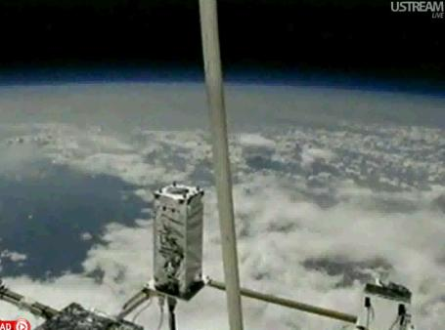

Fig.13 UND-UNF payload flying at altitude of about 37 km (Picture taken by “Cosmo Cam” video camera)

**Detection of ozone profile in the Starosphere**

Fig. 14 shows flow chart for the detection of oozne by the sensors payload during the flight.

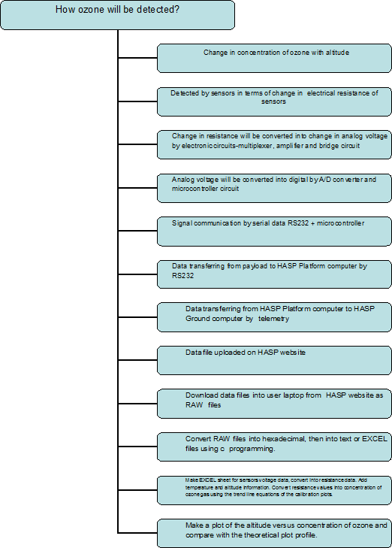

Fig.14 Flow chart for the detection of ozone by the payload

Fig. 15 shows the HASP 2010 balloon flight profile. The altitude profile was measured by the average of four GPS instruments. The flight duration was about 10 hours, while the average float altitude was about 39000 meters.

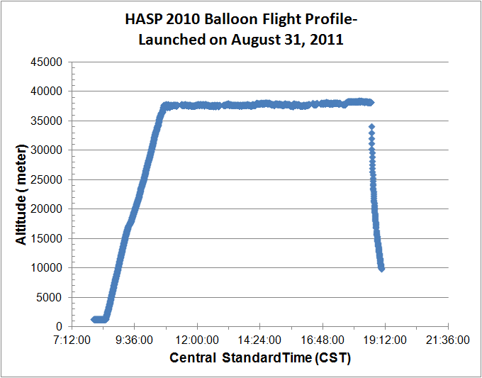

Fig. 15 HASP 2010 balloon flight profile

During the flight, UND-UNF sensors payload measured the ozone profile. The payload sent data files of 2KB every 9 to 10 minutes during the flight time through the NASA-HASP computer and was uploaded on the HASP website. We downloaded all the RAW data files, and converted RAW files into one EXCEL file using the software program. It was found that the sensors, hardware and software worked very smoothly. There was no need to upload the special commands to reboot the payload system during the flight.

Fig.16 shows the variation of temperature of sensors with altitude during the flight. The temperature of sensors was controlled in the range of 25 to 35 oC using an On-Off controller, a heater and a temperature sensor. Temperature of sensors was well controlled during the most of time of the flight. During the last two hours of the flight, temperature of sensors was increased up to about 46 oC due to the some problem. We suspected the problem may be with a current sensor at the position #7 of the HASP platform because we noticed similar issue during the thermal vacuum test.

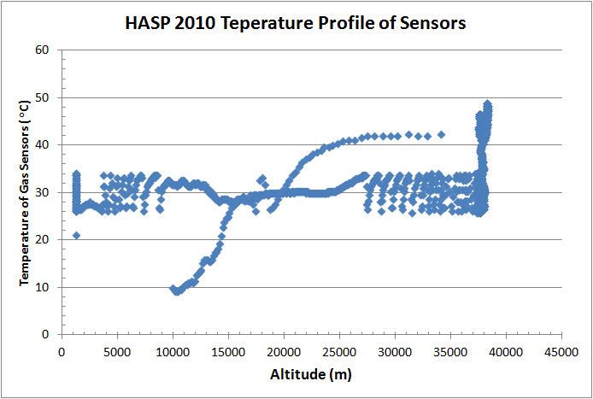

Fig.16 Temperature profile of sensors

**Discussion of Measured Data**

Sensor (#11) was randomly picked for the discussion of response of sensor with the altitude. Fig. 17 shows how the variation of resistance of sensor#11 with the altitude of balloon. The nature of plot looks complex at the first glance. We divided the plot of fig. 17 into three zones. Zone-A is rounded by the red color line. This zone has altitude from ground level to about 17000 meter. This region is known as the troposphere. The resistance of sensor was decreased with increase of altitude up to 17000 meter due to interaction of the sensor surface with most of reducing gas presence in the atmosphere and troposphere. Note that there was no effect of cold temperature on sensor because temperature of gas sensors was controlled and maintained to about 25 to 35 oC. The amount of ozone in this zone is very low compared to that of available pollutant gases, which was not measured correctly due to interference of the large amount of reducing gases. The resistance of ozone sensor was increased from altitude 17000 meter to about 33000 meter and then started to decrease. This region is known as the stratosphere. We are interested to measure the ozone profile in this region. The concentration of ozone is higher in the middle of stratosphere in the presence of ultra violet rays from the sunlight. Ozone is oxidizing gas and its concentration depends on amount of available Sun light. Upon adsorption of charge accepting molecules at the vacancy sites from ozone oxidizing gas, the electrons are effectively depleted from the conduction band of n-type Indium tin oxide (ITO) semiconductor sensor. Thus, this leads to an increase in the electrical resistance of n-type ITO gas sensor. At the maximum float of balloon, the concentration of ozone should be constant, but it may vary due to mixing ratio and availability of ultra violet rays from the sunlight. After termination of balloon, the payload again entered into the middle of stratosphere, the resistance of sensor should again increase and then decrease. The data on plot needs to zoom in to find this observation. That peak is not so large to observe in the fig.17 due to fact that the payload was dropping at the higher speed than that of the upward journey, non availability of ultra violet during night time and termination of power. This region is rounded by black color line and labeled as zone-B. We observed similar observations in the most of sensors. Based on this discussion and fact, we filtered out the data of zone –A and Zone-B and further worked over the data for the stratosphere only.

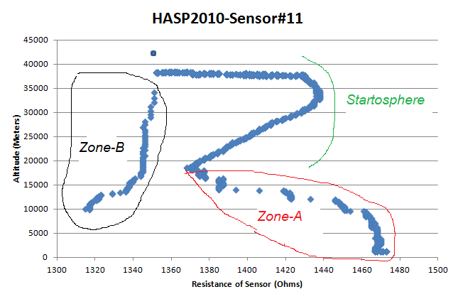

Fig.17 Response of ozone sensor#11 with altitude

The data of following sensors were good and hence considered for the further analysis:

**Group#1:** Nanaocrystalline ITO Sensor # S1, S4, S13, S14, S15 and S16

**Group#2:** Nanaocomposite of ZnO and ITO Sensor # S5, S6, S7, S8, S17, S18, S19 and S20

**Group#3:** Nanaocomposite of WO3 and ITO Sensor # S11 and S23

Fig.18 (a) to (p) shows the variation of ressitance of sensor with altitude.

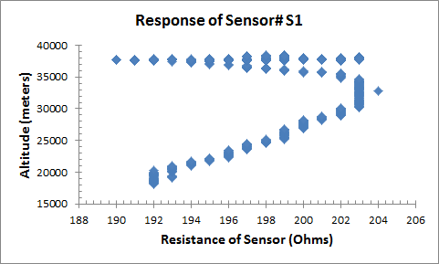 Fig. 18(a)

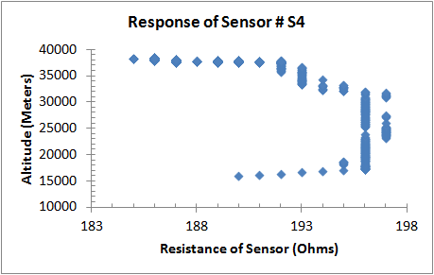 Fig. 18(b)

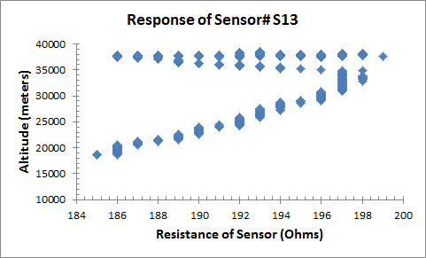Fig. 18(c)

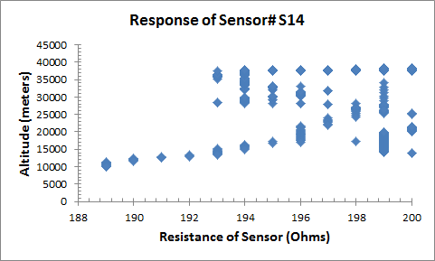 Fig. 18(d)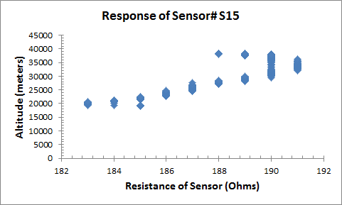 Fig. 18(e) Fig. 18(f)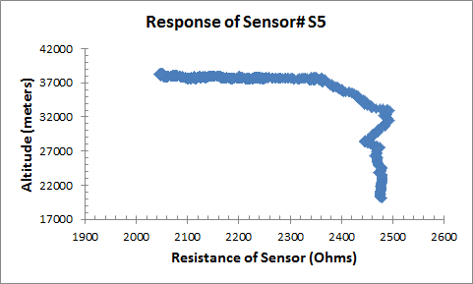 Fig. 18(g)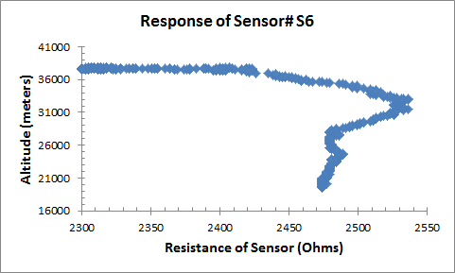 Fig. 18(h)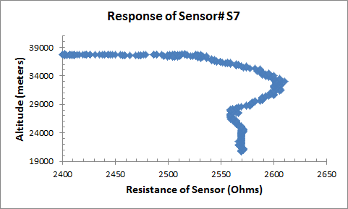 Fig. 18(i)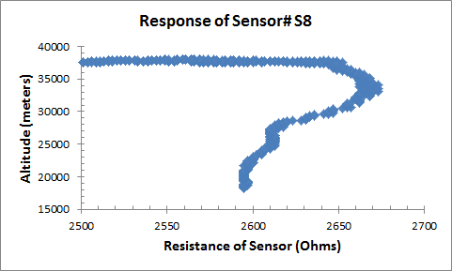 Fig. 18(j)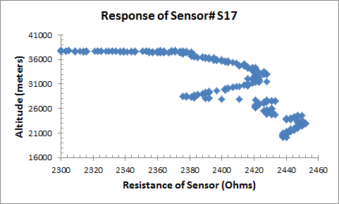 Fig. 18(k)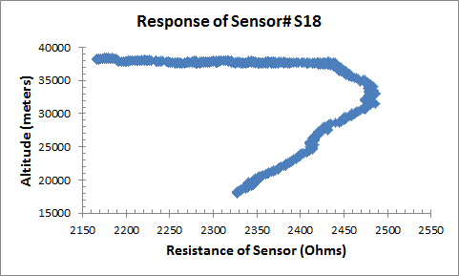 Fig. 18(l)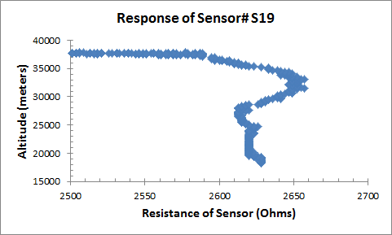 Fig. 18(m)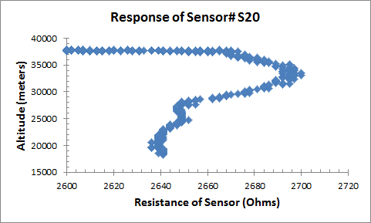 Fig. 18(n)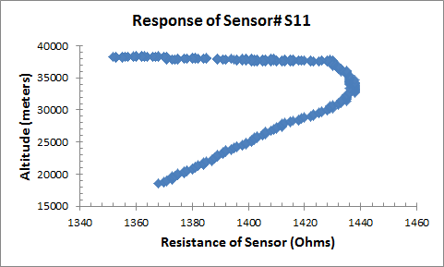 Fig. 18(o)

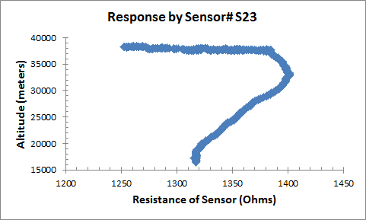 Fig. 18(p)

Using fig. 5(a) to (r), the trend line equation of calibation plot of each sensor was applied to convert the resistance values of the sensors into concentration of ozone gas in ppm. The trendline equations for each sensors were listed in the following table-1.

Table-1 Trendline Equations determined from the calibration plots (fig.5 (a) to (r)) of sensors

|  |  |  |  |
| --- | --- | --- | --- |
| Group# 1 | | | |
| Concentration of O3 (= x) (ppm) | | | |
| Sensor# |  | **Sensor#** |  |
| 1 | x = (y-186.0)/2.4 | 13 | x = (y-180.8)/2.4 |
| 2 | ---- | 14 | x = (y-180.0)/2.5 |
| 3 | ---- | 15 | x = (y-171.0)/2.4 |
| 4 | x = (y-179.0)/2.3 | 16 | x = (y-175)/2.52 |

|  |  |  |  |
| --- | --- | --- | --- |
| Group# 2 | | | |
| Concentration of O3 (= x) (ppm) | | | |
| Sensor# |  | **Sensor#** |  |
| 5 | x = (y-1450.0)/132.0 | 17 | x = (y-1450.0)/132.0 |
| 6 | x = (y-1465.0)/135.0 | 18 | x = (y-1465.0)/135.0 |
| 7 | x = (y-1565.0)/134.0 | 19 | x = (y-1715.0)/136.0 |
| 8 | x = (y-1650.0)/135.0 | 20 | x = (y-1630.0)/138.0 |

|  |  |  |  |
| --- | --- | --- | --- |
| Group# 3 | | | |
| Concentration of O3 (= x) (ppm) | | | |
| Sensor# |  | **Sensor#** |  |
| 9 | ---- | 21 | ---- |
| 10 | ---- | 22 | ---- |
| 11 | x = (y-1130.0)/39.0 | 23 | x = (y-1110.0)/39.0 |
| 12 | --- | 24 | ---- |

The trend line equation of the calibration plot is given as:

***y*** (sensor resistance) = [***m*** (slope). ***x*** (concentration of ozone, ppm)] + ***b***(y intercept)

The concentration of ozone gas can be determined by:

$$x=\frac{(y-b)}{m}$$

With these equation parameters, we obtained the following the ozone profile plots shown in fig.19 (a) to (p):

**Group: 1 Nanocrystalline ITO Sensors**

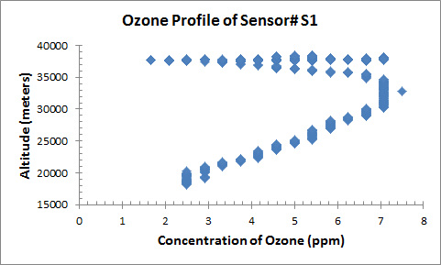Fig.19 (a)

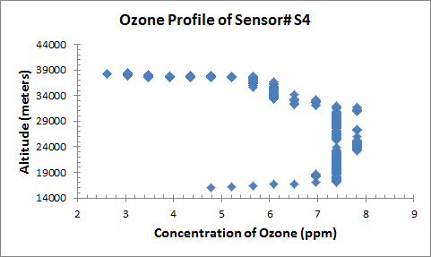 Fig.19 (b)

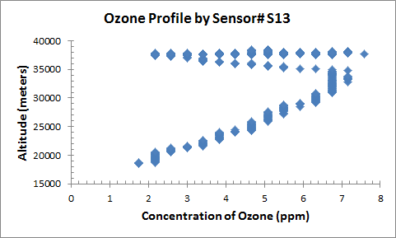 Fig.19 (c)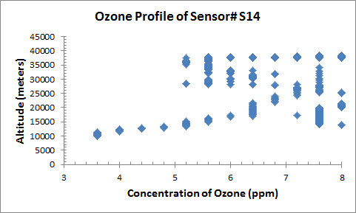 Fig.19 (d)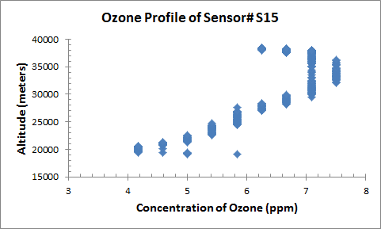 Fig.19 (e)

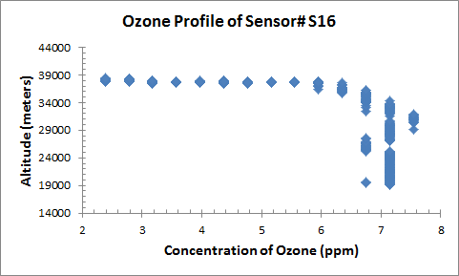 Fig.19 (f)

**Group: 2 Nanocomposite of ZnO and ITO sensors**

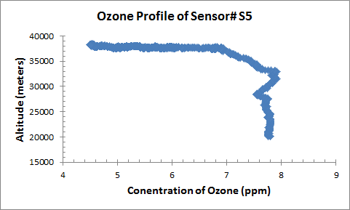 Fig.19 (g)

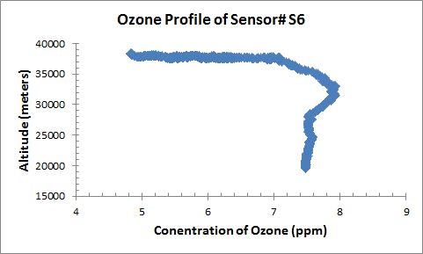 Fig.19 (h)

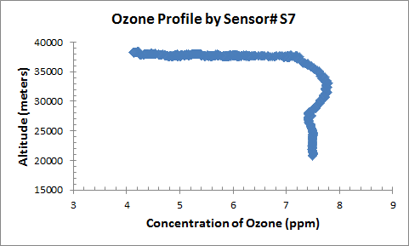 Fig.19 (i)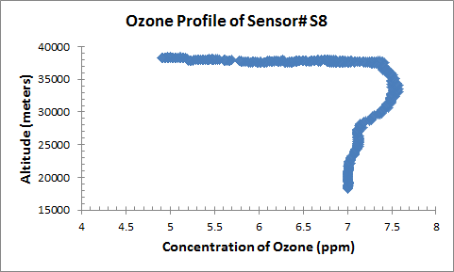 Fig.19 (j)

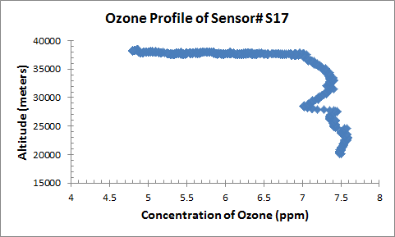 Fig.19 (k)

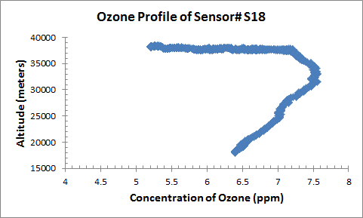 Fig.19 (l)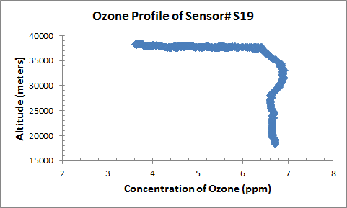 Fig.19 (m)

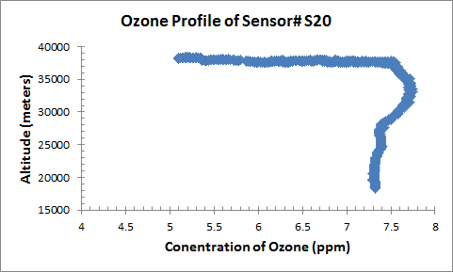 Fig.19 (n)

**Group: 3 Nanocomposite of WO3 and ITO sensors**

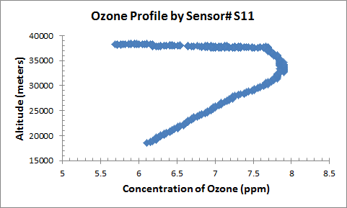 Fig.19 (o)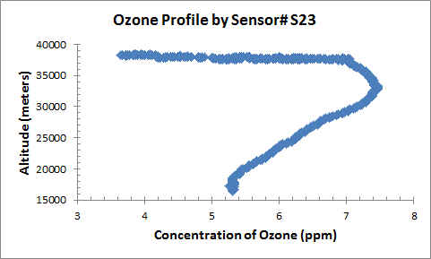 Fig.19 (p)

Fig.19 Measured ozone profile by sensors payload in the stratosphere

The nature of ozone profiles measured by the group #1, #2 and #3 sensors are nearly matched with the theoretically predicted profile, which is shown in Fig. 20 and 21 for the comparison purpose. The measured value of maximum concentration of ozone was observed from 7.4 to 8.0 ppm, which is very close to the expected values.

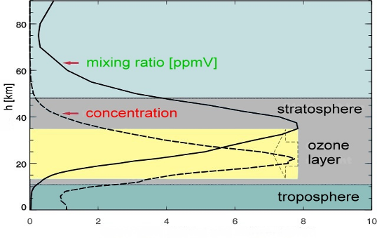

Fig. 20 Theoretical ozone profile in the stratosphere **(**[**http://www.atmosphere.mpg.de/enid/1yy.html**](http://www.atmosphere.mpg.de/enid/1yy.html)**)**

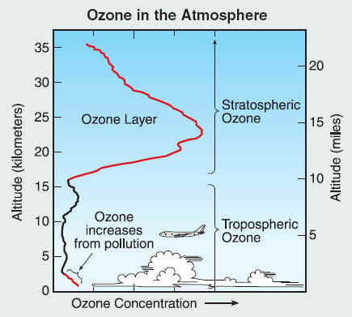

Fig. 21 Ozone profile in the atmosphere

**Problems and analysis**

1. Temperature of sensors was increased during last 2 hours of the flight. We checked the circuit board after recovering the payload and found everything was normal. The current sensor of position#7 of HASP platform need to be checked, which is not in our control. We request Mike (LSU) to look into this issue on HASP.
2. Sensor#12 and 24 of Group#3 did not give good data. These two sensors are on the bottom of the glass and PCB. We inspected these two sensors after recovery of the payload and found okay. These two sensors may not able to expose to ozone due to poor circulation of air.

**Conclusion**

1. The nanocrystalline and nanocomposite ozone sensors fabricated by the UNF team were integrated with the electronic circuits developed by the UND team in 2010. The payload successfully passed two times thermal vacuum tests in 2010 and 2011. Sensors worked well and measured the ozone profile in the stratosphere in 2011. The nature of measured profiles of most of sensors were nearly matched the theoretical profile.
2. UND-UNF team is interested to improve sensors payload and seeking another opportunity for the HASP 2012flight.

**Acknowledgements**

We are very grateful to

1. Dr. Gregory Guzik and Mike, HASP-LSU for their valuable help, cooperation and encouragement
2. Columbia Scientific Balloon Facilities (CSBF)-NASA, Palestine TX and Fort Sumner, NM, and team of CSBF
3. Florida Space Grant Consortium for providing the financial support to UNF team
4. Dr Jaydeep Mukherjee, Director, Florida Space Grant Consortium(FSGC) and Ms. Sreela Mallick, FSGC for their valuable help and encouragement
5. North Dakota Space Grant Consortium for providing the financial support to UND team
6. Department of Defense, US Army, Edgewood Chemical & Biological Center (ECBC), APG, MD