The High Altitude Student Platform (HASP) for Student-Built Payloads

T. Gregory Guzik and John P. Wefel

Department of Physics and Astronomy, Louisiana State University, Baton Rouge, LA 70803, USA

Abstract

An outstanding issue with aerospace workforce development is what should be done at the university level to attract and prepare undergraduates for an aerospace career. One approach adopted by many institutions is to lead students through the design and development of small payloads (less than about 500 grams) that can be carried up to high altitude (around 30 kilometers) by a latex sounding balloon. This approach has been very successful in helping students to integrate their content knowledge with practical skills and to understand the end-to-end process of aerospace project development. Sounding balloons, however, are usually constrained in flight duration (~30 minutes above 24 kilometers) and payload weight, limiting the kinds investigations that are possible. Student built picosatellites, such as CubeSats, can be placed in low Earth orbit removing the flight duration constraint, but the delays between satellite development and launch can be years. Here we present the inexpensive High Altitude Student Platform (HASP) that is designed to carry at least eight student payloads at a time to an altitude of about 36 kilometers with flight durations of 15 to 20 hours using a small zero-pressure polyethylene film balloon. This platform provides a flight capability greater than sounding balloons and can be used to flight-test compact satellites, prototypes and other small payloads designed and built by students. The HASP includes a standard mechanical, power and communication interface for the student payload to simplify integration and allow the payload to be fully exercised. In addition, HASP is lightweight and has simple mission requirements providing flexibility in the launch schedule. In this fashion, a higher education student aerospace payload program can be assured of a flight test opportunity at the end of each academic year.

1. Introduction
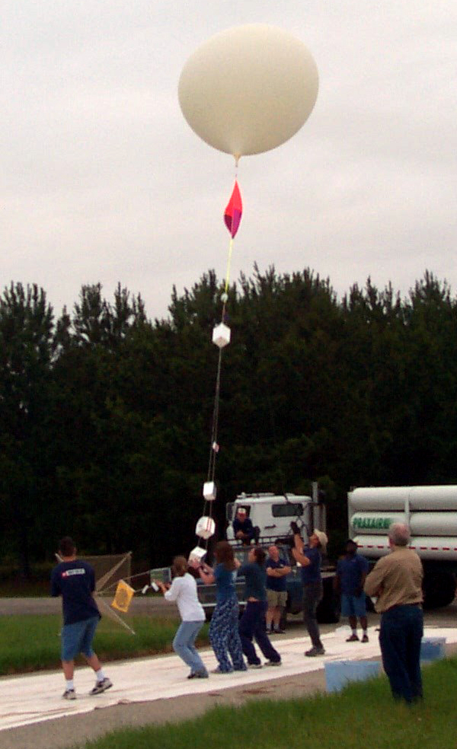
Figure 1: The ACES-01 launch

Supporting and training students to participate in the aerospace workforce is currently a major mission of NASA. One program that, to date, has excited and involved hundreds of students throughout the nation is the National Space Grant Student Satellite Program. Using the “Crawl, Walk, Run, Fly” methodology, 32 higher education institutions across the country are engaging students in the design, construction and operation of aerospace payloads ranging from simple balloon experiments to compact Earth-orbiting satellites. A development life cycle, culminating in the exciting launch and flight operations, for one of the student payloads typically needs to be limited to one year to conform to student class scheduling. This one year cycle is feasible for balloon payloads where launch is relatively simple, inexpensive and flexible, but is much more difficult to realize for the student satellites where the launch schedule is dependent upon rocket booster availability. In fact, student satellites can be in storage for months or even years as negotiations proceed with rocket vendors or government institutions to provide a ride to low Earth orbit and while the primary payload is. readied for launch.
One solution might be to launch the completed student satellite, at the end of the academic year, on a latex sounding balloon as a test flight. Sounding balloons can carry up to 12 pounds of payload to altitudes exceeding 100,000 feet and many states already have active student balloon payload development and launch programs. Figure 1 shows the launch of the first Aerospace Catalyst Experiences for Students (ACES) balloon, that carried three payloads constructed by Louisiana State University (LSU) and Southern University (SU) students to an altitude of nearly 100,000 feet (Guzik, 2003; Ellison et al. 2004). Following such a test flight, the student built satellite could then be prepared, including modifications to correct issues revealed during the test flight, for launch to Earth orbit. In this fashion, the student group would be able to experience a sense of completion to their year long effort that may maintain their (or their younger colleagues) excitement in the project until actual reception of the satellite signal from Earth orbit.
One major problem with the sounding balloon launch is that such flights are likely to be too short in duration and altitude to fully exercise and test a student satellite. Figure 2 shows the altitude versus time profile for the ACES-01 flight and is typical of such sounding balloon flights. Note that the entire flight, launch to landing, lasted a little more than 2 ½ hours and that only about a ½ hour was spent at altitudes in excess of 24 kilometers. With such short durations at altitude the student satellite would not be able to evaluate thermal effects (i.e. there would be no day / night cycle) and there would only be time for the most cursory evaluation of the satellite power, data acquisition and telemetry subsystems. Longer durations at high altitude are needed to provide an effective test flight for a student satellite.
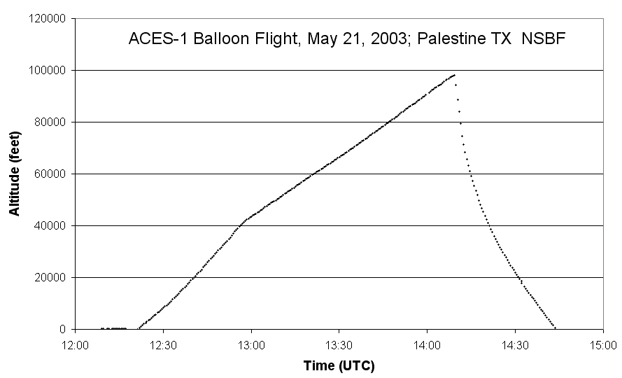
Figure 2: Altitude vs time profile for the ACES-01 flight.
The sounding balloon flight duration limitation is partly the result of simplifying flight termination operations by merely allowing the balloon to reach a peak altitude where it bursts and the payload descends on a parachute. However, there is an extensive body of experience in scientific ballooning available through the NASA National Scientific Balloon Facility (NSBF) that for multiple decades has flown payloads weighing up to several tons to altitudes up to 160,000 feet for durations up to 30 days using zero-pressure polyethylene film balloons. The full NSBF capability far exceeds what is required for most student payloads and what is needed is an inexpensive, reusable “ballooncraft”, tailored to accommodate complex student-built payloads, that makes extensive use of existing designs, hardware and support systems.
The High Altitude Student Platform (HASP) would address this need to provide an intermediate step between sounding balloon and low Earth orbit launches. HASP would be based upon existing, flight proven designs to minimize development cost, would be able to accommodate multiple student payloads during a single flight and would provide a standardized mechanical, power and telemetry interface for each payload. The use of a standardized vehicle flown by NSBF would simplify flight operation logistics and allow institutions to focus the students on building their payloads. Further, and perhaps more important, HASP would allow the size, weight, power and telemetry limitations imposed by the sounding balloon or CubeSat launch models to be significantly raised. With HASP a 30 pound, 1 foot cube, 20 Watt payload would not be excessive. This opens the door to more advanced and complicated student built experiments. In fact, while HASP is currently conceived for “short” 20 hour Continental US flights, a slightly modified version of HASP could easily be used for 15 – 30 day long duration balloon (LDB) or ~100 day ultra long duration balloon (ULDB) flights.

2. The HASP Hardware

The HASP system is designed to support and fly multiple student built payloads to altitudes of 120,000 feet or greater for flight durations that could exceed 20 hours. The platform is built from components that are either immediately available or have proven flight histories in order to minimize development and operation cost. Student payloads attach to HASP via a standard interface that provides the payload with power, command uplink, data downlink and hard attach points.

2.1 The Cubesat Model

To constrain the initial design for the HASP student payload interface we adopted a model based upon the “CubeSat” student built picosatellite form factor developed by Stanford University and California Polytechnic State University (ref). Many CubeSats have already been built by students at institutions around the world as part of student training, space test and, potentially, advanced industry training programs. As specified in the “CubeSat Design Specifications Document” (Puig-Suari and Twiggs, 2003), each CubeSat must be a 10 cm cube, weigh no more than 1 kilogram and include four “deployer” corner post with separation springs and deployment detector switches embedded in their ends. In addition, much of the CubeSat surface could have deployable antennas or instrument booms. The HASP mechanical interface needs to take these features into account.
The design standard specifies that a data / power port must be provided if the satellite requires testing or battery charging, but does not include any further details. We therefore assume that payloads will be able to provide a serial uplink / downlink through the access port and that power requirements will be driven by the use of commercial-off-the-shelf (COTS) low power, compact CPU / electronics boards and HAM radio transceivers. Thus, budgeting ~500 mW @ 3.6V and ~150 mW @ 5V for each HASP student payload during this concept design would be appropriate. During final design we will solicit input from potential HASP users on their power and serial communication requirement and preferences.
Finally we assume that on-orbit, CubeSats are usually designed to uplink and downlink on frequency bands allocated to the amateur-satellite service. The International Amateur Radio Union Satellite Advisor, has established a set of guidelines, which govern coordination of these frequencies. If a particular CubeSat payload needs to operate their transceiver during flight, the transmit and receive frequencies will need to be compatible with the HASP systems.

2.2 Configuration & Structure

Figure 3 shows a concept configuration for the HASP balloon payload with thermal shielding removed. The core structure of the platform is a welded aluminum gondola frame with dimensions of 112 cm long, 91.5 cm wide, 51 cm tall that weighs approximately 45.4 kilograms. Suspension cables would run from the four corners of the aluminum frame to a swivel that would attach to the flight train. A ballast hopper and crush pad would be mounted below the frame.
Mounted on the interior of the frame would be the Consolidated Instrument Package (CIP) that provides NSBF with control over the balloon systems. The CIP passes uplinked commands to the HASP control system, which consists of the Flight Control Unit (FCU), the Data Archive Unit (DAU), the Archive Data Disk and the Auxiliary Transmitter. The hardware design and controlling software for the FCU, DAU, archive disk and auxiliary transmitter were developed under the NASA supported Advanced Thin Ionization Calorimeter (ATIC) long duration balloon project at Louisiana State University (ref) and can be easily adapted to HASP. The data disk, FCU and DAU would be mounted in a pressure vessel and the NSBF supplied auxiliary transmitter would already be high altitude qualified. Also mounted in the interior of the frame would be the lithium cells that supply power to the HASP systems and student payloads. Thermal insulation will be mounted on the core frame to maintain the electronics and battery temperature as well as to thermally isolate the CIP from the rest of the HASP components.
Attached to the core structural frame are four fiberglass or similar composite material braces that are used to support the student payloads. Each brace extends 112 cm away from the aluminum frame and supports two student payload mounting plates. Each student payload mounting plate would include standard mechanical, power and serial communication interfaces. One such brace is attached to each side of the core structure to accommodate at least eight student payloads. This configuration was chosen to minimize interference between the metal frame and any student payloads that may exercise their transmitters during flight.
Student payloads that might want to use HASP as a launch vehicle could deviate in dimensions from the CubeSat specification. If this is the case then the mechanical interface for such payloads will consist of a bolt hole pattern on the extension braces, the power and data connectors and a maximum volume and weight. It would be up to the student group to design and fabricate a secure mounting plate for their payload. Further, student payloads designed for HASP that are significantly heavier or larger than the CubeSat specification could be mounted directly on the top surface of the aluminum gondola frame which would be strong enough to support their weight even under maximum flight loading conditions.
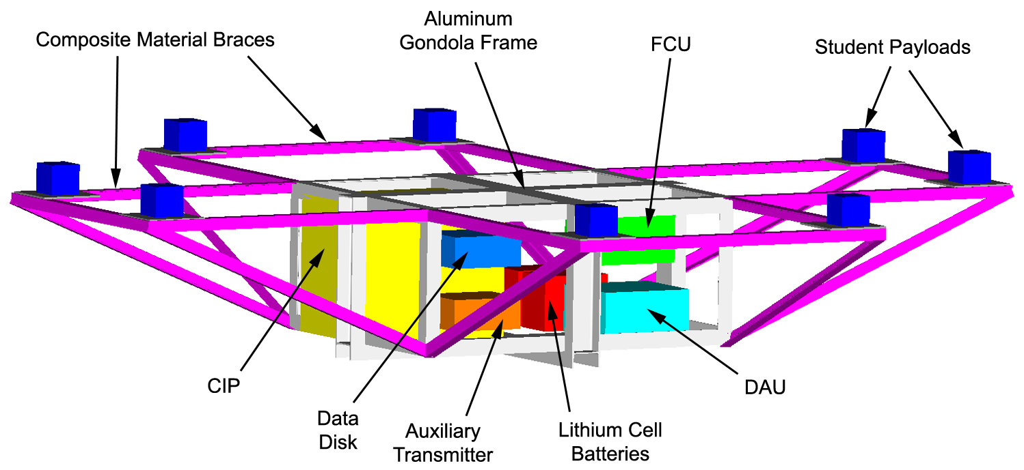
Figure 3: The HASP configuration
Table 1: HASP Weight Budget
Component | Weight (kg)
Fight Control Unit | 2.3
Data Archive Unit | 2.3
FCU, DAU Vessel | 18.1
Data Hard Disk | 9.1
Auxiliary XTM | 2.3
Student Payloads | 8.2
Cabling | 13.6
Thermal Insulation | 13.6
Batteries | 9.1
Structure | 68.9
CIP | 27.2
Contingency | 36.3
Total | 211

The estimated weight budget for HASP is given in Table 1. Measured weights are available for the FCU, DAU, data hard disk, core aluminum frame, CIP, auxiliary transmitter and batteries. The student payload weight was determined by including eight CubeSats at ~2.2 pounds each. The weight for the extension braces was calculated and estimates for additional mounting structure, cabling, thermal insulation and the FCU, DAU pressure vessel is based upon our experience with ATIC. Including a contingency of 80 pounds the total HASP weight is estimated at 465 pounds. A small (1 million cubic foot) balloon is able to carry a 600 pound payload to an altitude of ~120,000 feet for a flight duration of about 20 hours.

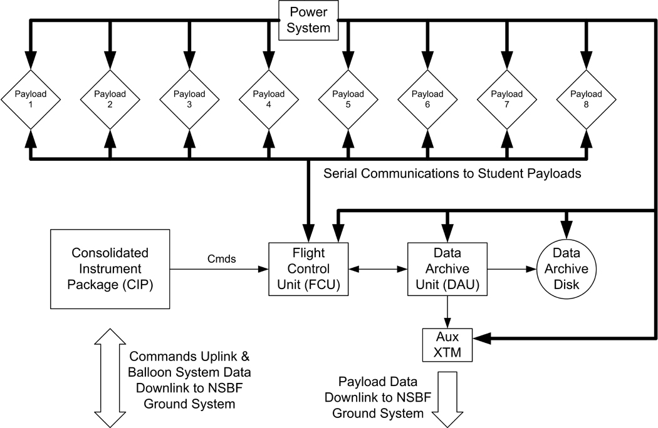
Figure 4: HASP command and control system

2.3 Command & Control

The HASP command and control subsystem, illustrated in Figure 4, provides the means for receiving and processing uplinked commands, acquiring and archiving the payload data, downlinking status information and controlling the student payloads. There are two primary modules in the subsystem; the Flight Control Unit (FCU) and the Data Archive Unit (DAU). The FCU "manages" the subsystem; decoding commands received from the NSBF supplied CIP and distributing them, watching for units that may need to be reset, and collecting status data for downlink. In addition, the FCU also monitors the power system, collects pressure and temperature information for housekeeping records and provides a serial communication link to each of the student payloads. The DAU controls the on-board recording of all data to a hard disk drive as well as transmitting housekeeping and student payload data to the ground during times when the payload is within line-of-sight (LOS). The existing design supports a ~300 kilobit per second downlink rate, which should be more than sufficient to telemeter all student payload data. On-board recording of these data to the archive disk is a backup in case LOS is lost for any reason.
All modules run the QNX real-time operating system, which is POSIX complaint and facilitates programming across a distributed environment. Flight software processes on different modules communicate across an internal payload ethernet using a client / server message passing scheme. The software is event driven where the "events" are classified as particle triggers, timeouts, commands and messages. The HASP flight software would be essentially identical to that already developed for the ATIC experiment with the exception that additional serial communication processes would need to be added to accommodate the student payload and a student payload data record would need to be defined.
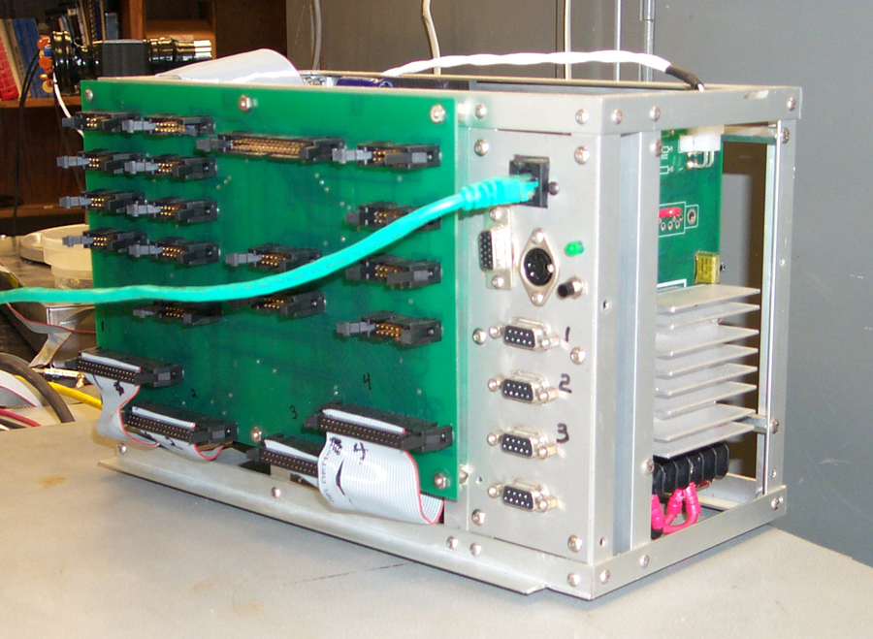
Figure 5:Front view of the Flight Control Unit (FCU)
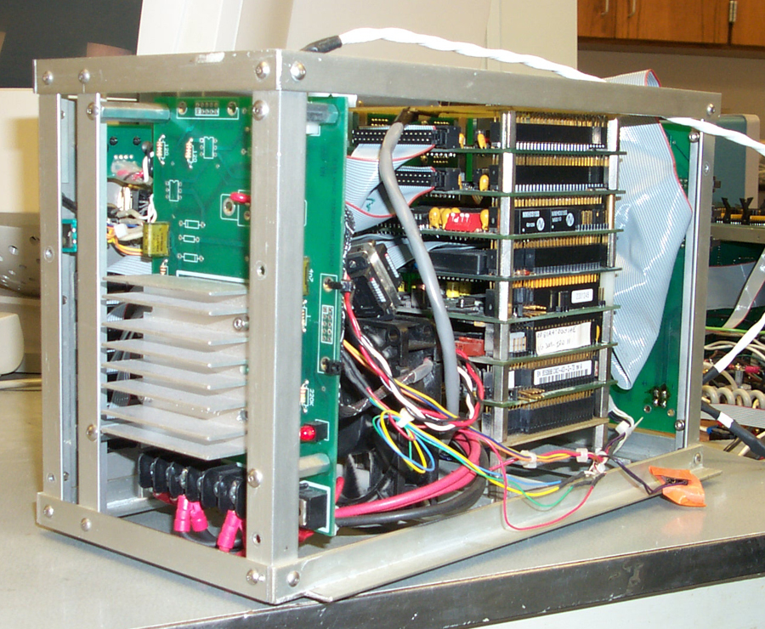
Figure 6: Back view of the Flight Control Unit (FCU)
Each module stack is built from available PC/104 "Intel class" CPU, I/O, and peripheral control cards. The FCU that was flown on the ATIC-02 flight during 2003 is shown in Figures 5 and 6 and is essentially identical to what would be flown on HASP. The front panel (Figure 5) includes ports for the 100BaseT payload network, keyboard and video connections for running internal diagnostics during ground testing, serial links for communication to the NSBF control systems, as well as connectors for digital I/O and ADC lines for monitoring the payload environment and controlling the power system. The back view of the FCU (Figure 6) shows the local 28 V to 5 V DC-DC converter (left side) and the stack of PC/104 cards (right side). For HASP the FCU would be slightly modified by removing the digital I/O cards and adding serial communication cards. The DAU for HASP would be identical to that used for ATIC and would consist of a PC/104 stack, local DC-DC converter and an Ethernet switch. The FCU, DAU and data archive disk would all need to be contained within pressure vessels for correct operation and thermal control. Pressure vessel designs that would serve this purpose are already available.
Table 2: HASP Power Budget
Component | Volts | Amps | Watts
FCU | 5 | 3.5 | 17.5
DAU | 5 | 3.9 | 19.5
Aux XTM | 5 | 1.3 | 6.5
Data Disk | 5 | 0.8 | 4.0
Data Disk | 12 | 1.3 | 15.6
Student Payloads | 5 | 0.3 | 1.5
Student Payloads | 3.6 | 1.4 | 5.1
Total |  |  | 69.7

2.4 Power System

A schematic of the HASP power system is shown in Figure 7. The primary power source is anticipated to be two 10 cell lithium battery packs which would supply 28 Volts for ~60 Ahr. The HASP power system closely follows the ATIC experiment design so subsystem components can be readily reproduced. In this concept, the 28 V bus is run through the gondola and required voltages are converted locally. This approach simplifies the gondola wiring and minimizes power loss. Each supply in the power system includes a relay to control the flow of power via discrete on and off commands, an appropriate DC-DC converter and voltage / current sensors that are used to monitor the state of the power system. Voltage / current sensors are also placed on the main 28 V bus. The diagram in the dashed box represents the power supply for a student payload assuming the CubeSat model. There would be one such unit for each student payload attached near the payload mounting plate and wired through the power interface connector.
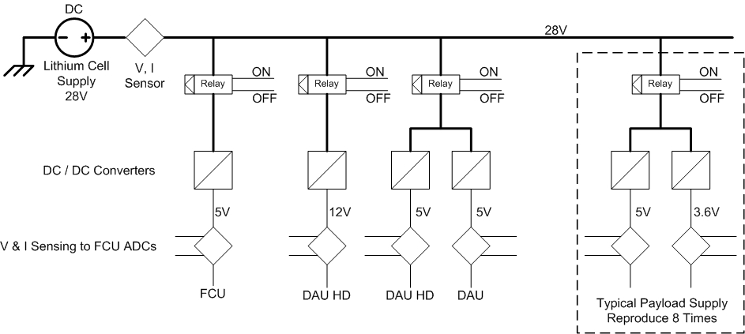
Figure 7: HASP power sub-system with example payload supply
The anticipated HASP power budget is shown in Table 2. The required voltages and expected power draw is indicated for each of the components. Power consumption for the FCU, DAU and Data Disk are based upon the ATIC flight experience, that for the Aux XTM is an estimate and eight Student Payloads were included. Power system inefficiency was taken into account by dividing the actually current draws by 80%. Thus, with a full complement of student payload it is expected that HASP will consume about 70 Watts of power. At 28V this corresponds to about 2.5A from the lithium cells or, with two cell packs on board, about a 24 hour lifetime

3. The HASP Operation Plan

HASP flight operations are planned to occur yearly. At the beginning of each academic year we will gather information about student payloads that would potentially fly the following summer. A “solicitation” package will be distributed that will include information about the HASP opportunity, capability and constraints as well as a “flight application” that would need to be filled out with information about the candidate payload (mechanical, power, communication, deployables, etc.) and submitted. This information would then be used to plan flight operations.
A detailed schedule of events during one such flight mission is shown in Figure 8. Late April to early May HASP is packed and shipped to the NSBF in Palestine, Texas, where it is unpacked, assembled, integrated with the CIP and fully tested. We expect the students groups to arrive at NSBF toward the beginning of May and prepare their payloads for integration. The student payloads will be checked for proper mechanical, power and communication interface and mounted on HASP one at a time. After all student payloads are mounted and verified for correct operation with HASP the full “hang test” will occur. During the “hang test” HASP will be connected to the flight train, parachute and terminate packages, “hung” on the launch vehicle and tested end-to-end for communication and proper operation.
Following the “hang test” the Flight Readiness Review (FRR) will verify that all systems are ready and a weather briefing will identify potential launch opportunities. We are targeting HASP launches for the end of May to beginning of June or slightly after Palestine “turnaround” (when the prevailing easterly high altitude winds change or “turn around” to prevailing westerly) to assure the longest west going flight. As the occurrence of “turn around” is not always predictable, waiting for proper launch conditions may last several weeks.
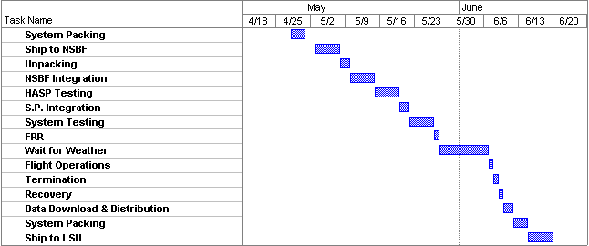
Figure 8: Anticipated HASP flight operation schedule
Once HASP is launched we would anticipate a 6 to 20 hour flight. During the flight the student payloads would be exercising their systems; accepting / executing commands and collecting data. Student payloads that can make full use of the serial communication link with the HASP FCU would be able to operate throughout the entire flight. Commands would be uplinked to HASP and routed to the appropriate student payload, while data would be recorded on-board data disk as well as downlinked to the ground. The payload data would then be available to the student institution ground system. Student payloads that can not make full use of the serial link or would need to exercise their built-in transmitter would need to schedule time during the flight to not conflict with any other HASP or NSBF radio communication. Also during the flight the HASP systems will be continuously monitored to assure correct operation of the payload.
Following flight termination HASP will be recovered and returned to NSBF a day or two later. Copies of the data disk will be made along with flight key parameters (e.g. GPS latitude, longitude, altitude, time) and distributed to each student group for analysis. HASP would then be packed up and shipped back to LSU for refurbishment. Refurbishment of the HASP systems would begin toward the beginning of the calendar year. We would repair any damage that occurred to the mechanical, power and control subsystems during landing and recovery as well as replace spares as needed.

4. Conclusions

The High Altitude Student Platform (HASP) is being developed to support advanced student-built payloads and will fill a gap in capability between latex sounding balloon and satellite launch platforms. HASP will provide a regular schedule of launches of at least once per year and access to high altitude (~36 km) for a reasonable duration (up to 20 hours). The platform will include a standard power, data and mechanical interface and will be appropriate for flight testing student-built satellite prototypes or payloads too heavy for sounding balloons. To minimize the cost of development and operations HASP will make extensive use of existing flight designs and experience. In particular, most of the HASP systems will be based upon the hardware / software designs developed and flown on previous scientific balloon payloads. Further, we will capitalize on decades of NSBF experience in ballooning by using time-tested ballooncraft control hardware and their experience with flight operations. While HASP is initially designed to operate for short continental US flights, the basic design could be easily adapted for Long Duration Balloon flight providing students with inexpensive access to space for 15 to 30 days.

5. References

- “The Aerospace Catalyst Experiences for Students (ACES) Project”, T. Gregory Guzik, Invited presentation to the Suborbital Center of Excellence Annual Student Conference, April 30, 2003 and available at http://laspace.lsu.edu/aces/Presentations.html.
- “The Advanced Thin Ionization Calorimeter (ATIC) for Studies of High Energy Cosmic Rays”, Guzik, T. G., et al., the ATIC Collaboration, Proc. 26th Int. Cosmic Ray Conf. (Salt Lake City), 5, 9, 1999
- “The ATIC Long Duration Balloon Project”, T. G. Guzik, et al., the ATIC Collaboration, Advances in Space Research, (in press), 2003
- “CUBESAT Design Specification Document”, Revision VIII, August 2003, Jordi Puig-Suari, California Polytechnic State University and Bob Twiggs, Stanford University, http://cubesat.calpoly.edu/_new/documents/cubesat_spec.pdf
- “Development of the Standard CubeSat Deployer and a CubeSat Class PicoSatellite”, Jordi Puig-Suari, Clark Turner, William Ahlgren, IEEE, 0-7803-6599-2/01, 2001 and available at http://cubesat.calpoly.edu/reference/cubesat_paper.pdf
- “Development of a Family of Picosatellite Deployers Based on the CubeSat Standard”, Isaac Nason, Jordi Puig-Suari, Robert Twiggs, IEEE, 0-7803-7231-X/01, 2002 and available at http://cubesat.calpoly.edu/reference/ppod_paper.pdf
- “The Electronic System Design, Analysis, Integration, and Construction of the CalPoly State University CP1 CubeSat”, Jake A. Schaffner, 16th AIAA / USU Conference on Small Satellites, 2002 and available at http://cubesat.calpoly.edu/reference/cp1_paper.pdf
- “Amateur Radio Satellites: Information for Developers of Satellites Planned to Use Frequency Bands Allocated to the Amateur-Satellite Service”, The International Amateur Radio Union, IARU Amateur Satellite Advisor, 2001 and available at http://www.iaru.org/satellite/iarusatspecrev13.8.pdf

